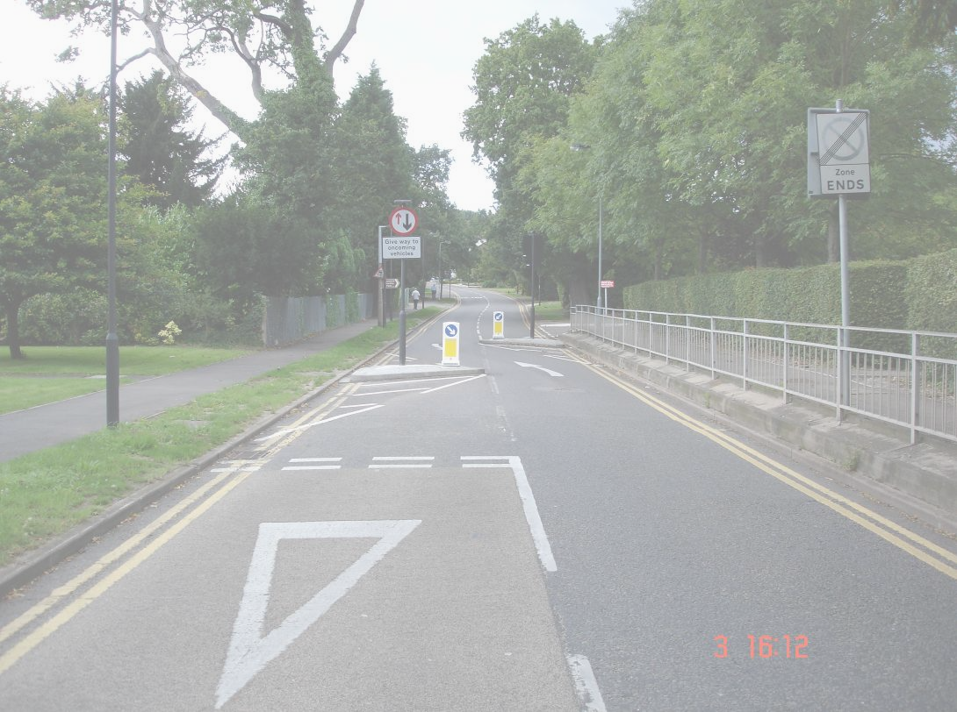
HARROW COUNCIL
ROAD SAFETY PLAN

October 2015

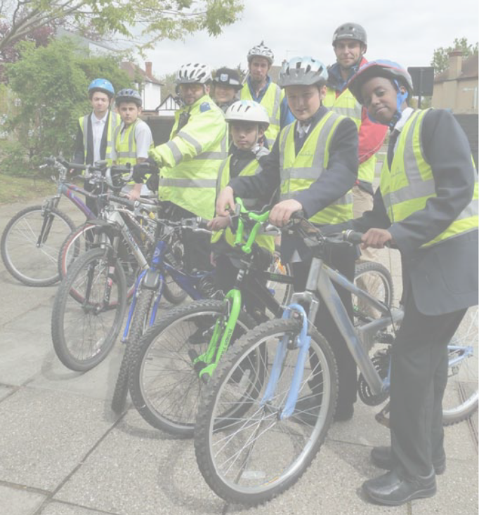

Making our roads safer

Contents
Page
1. INTRODUCTION 3
1.1 Statutory Framework 3
1.2 Policy Background 3
1.3 Overview of Casualty Reduction in Harrow 4
2. HARROW POLICIES 5
3. CASUALTY MONITORING AND TARGETS 6
3.1 National 6
3.2 London 6
3.3 Harrow 7
4. PERFORMANCE AGAINST LIP CASUALTY TARGETS TO DATE 8
4.1 Killed and seriously injured 8
4.2 Total casualties 9
4.3 Motorcycle casualties 10
5. TRENDS IN CASUALTIES 11
5.1 Children (0-15yrs) 12
5.2 Pedestrians and cyclists 14
6. EDUCATION, ENGINEERING AND ENFORCEMENT 15
6.1 Education and Training 15
6.1.1 Targets 18
6.1.2 Road Safety Resources 18
6.1.3 Road Safety Education Activities 19
6.2 Engineering 23
6.2.1 Accident reduction 23
6.2.2 Accident Prevention 24
6.2.3 20 mph zones 25
6.2.4 Local Safety Schemes 26
6.2.5 School Travel Plans 26
6.2.6 Localised Safety Parking Programme (LSPP) 27
6.3 Enforcement 28
6.3.1 Speed and red light cameras 28
6.3.4 Speed activated signs (SAS) 29
6.3.5 Speed limits 29
6.3.6 Civil enforcement officers (Parking attendants) 30
7. MONITORING 30
8 . PARTNERSHIPS 30
9. FUNDING 31
Appendix A: 20mph zones and traffic calmed areas n London Borough of Harrow 32
Appendix B: Road casualty maps 33
Appendix C: Effectiveness of Local Safety Scheme implementation 35
Appendix D: Location of speed and red light camera sites 36

INTRODUCTION

1.1 Statutory Framework

The Road Traffic Act 1988, Section 39, gave local authorities responsibility for all roads outside the motorway and trunk road system. This was superseded by the Greater London Authority Act 1999, which transferred responsibility for the Greater London Authority roads to Transport for London but left local authorities responsible for road safety on remaining roads within the local authority.

Local authorities are required by statute (Road Traffic Act 1988) to:
- Carry out a programme of measures designed to promote road safety on existing roads and in the construction of new roads.
- Undertake studies of personal injury accidents.
- Take appropriate measures to prevent such accidents.
- Provide road safety advice, information and practical training for road users.

The Council has a statutory duty to maintain the safe, convenient and free flow of pedestrian and vehicle traffic except where lawful restriction of speed direction or movement of traffic is imposed by a legal order. The Council has powers as a highway authority under the Highways Act 1980 to construct, manage, maintain and improve highways. It also has powers under the Road Traffic Act 1991 to enforce parking restrictions in order to promote road safety.

The Road Traffic Regulation Act 1984 places a duty on local authorities to secure the expeditious, convenient and safe movement of vehicular and other traffic, including pedestrians and cyclists, and the provision of suitable and adequate parking facilities on and off the highway and to have particular regard to:

- Reasonable access to premises;
- The effect on amenities; and
- Passage of public service vehicles and the safety of passengers.

1.2 Policy Background

Until 2011, National Governments and the Mayor of London had agreed and set road safety targets which were reported locally and nationally. This has now changed and a localism agenda has replaced the national target setting and the national road safety policy. This is intended to allow local authorities the freedom to address local road safety in the way that local residents and politicians deemed best fit.

In May 2011, the Government published its Strategic Framework for Road Safety. This moved away from national casualty targets towards monitoring road safety indicators. This strategic framework also sets out a wide range of measures to tackle careless and dangerous driving – including a new fixed penalty notice for careless driving and tougher action against drink and drug drivers. Also included is an Outcomes Framework designed to help improving road safety and decreasing the number of fatalities and seriously injured casualties on the roads.

The Government believes that road deaths could fall by around 37% to 1,770 by 2020 and road casualties could fall by 57% to below 10,000 in the same time period. The framework makes it clear that this is not a government target but is a realistic aspiration. The national reductions in deaths and casualties on the roads are largely expected to be achieved by bringing the worst performing local authorities up to the standards of the best performing authorities. As Harrow’s road safety is one of the best in the country it is not realistic that this sort of drop in fatalities or casualties on the roads will be achieved.

Other key policy influences on road safety in the borough are:

- The Mayor’s Transport Strategy which states that reducing the number of people killed or seriously injured in road traffic is a key goal for the Mayor; and
- Harrow Transport Local Implementation Plan 2014-16 which includes road safety targets for the borough which are agreed by the Mayor of London.

1.3 Overview of Casualty Reduction in Harrow

Harrow has a good tradition of promoting and prioritising road safety. This is reflected in the council’s personal injury accident record, which consistently shows that the number of casualties in Harrow each year is amongst the lowest of all the London Boroughs. In addition, Harrow has one of the lowest accident rate per head of population for all the London boroughs. See Figure 1-1 which shows the number of road accidents in 2014 compared to other outer London boroughs.

This Road Safety Plan sets out ways in which the Council intends to contribute towards the reduction of road accident casualties. The Plan sets out the education, training, engineering and enforcement programmes, which seek to ensure that roads are managed as safely as possible and in accordance with the statutory requirements.

The Council can only achieve a certain amount on its own and anyone involved in transport has a role to play in improving road safety. The Government, Transport for London, the Council, the Police, car manufacturers, all have a role in creating a safer environment for road users. Technology also plays an increasingly important part in the general enforcement of traffic regulations which also contributes towards improving road safety.

The Council’s efforts in recent years resulted in Harrow achieving the national accident reduction target set by the previous government for both killed or seriously injured and for slight injuries. This road safety plan sets out Harrow’s plans in ensuring that casualty reduction in Harrow continues to be reduced and shows the Council’s resolve in achieving road safety targets. The council is an active member of the London Road Safety Council which meets quarterly to discuss road safety matters across London.

The main factor in most accidents is the involvement of the car. In Harrow, car occupant casualties made up for 49% of all casualties in 2014. However, it should be noted that the borough has one of the highest number of households who own a car, and is among the highest of households that own 2 or more cars, yet still has one of the lowest casualty rates in London.

Figure 1-1
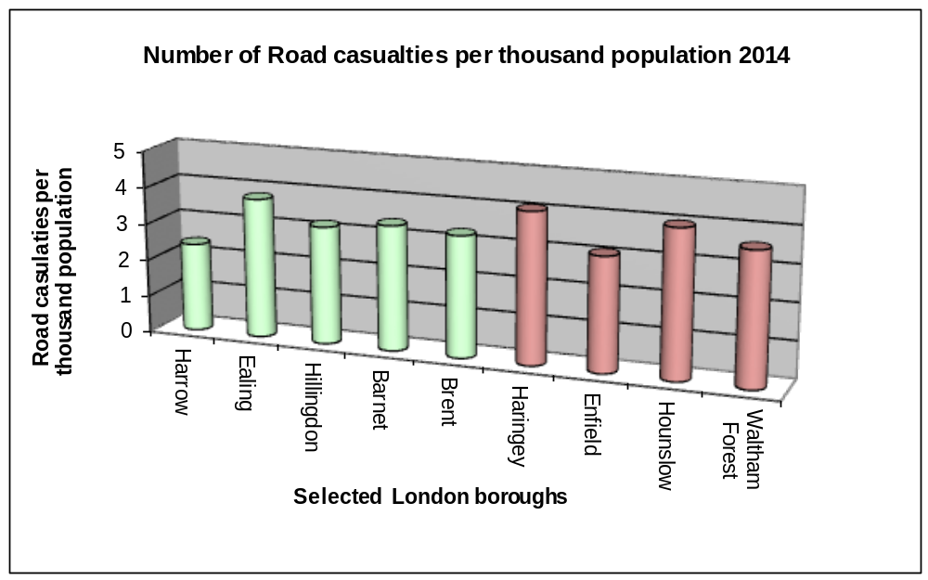

HARROW POLICIES

Harrow’s Transport Local Implementation Plan 2011/12 - 2013/14 contains the strategic policy actions that influence road safety within the borough. These policy actions have been developed and revised following wide scale public consultation. These policies are as follows:

R1 In the development of all corridors and neighbourhoods, the council will follow the detailed guidelines as outlined in the road safety plan.
R2 Monitor motorcycle casualties and develop a localised response to address locations where accidents arise prioritising actions according to the severity of casualties
R3 Maximise the effective use of camera enforcement where there are safety benefits to be gained from better enforcement.
R4 Adopt the national and London casualty reduction targets and maintain an effective method of accident monitoring for the borough
R5 Prepare a three year programme of 20 mph zones in the borough and incorporate these into neighbourhood schemes for TfL funding
R6 Reduce the number of motorcycle casualties in the borough through educational campaigns
R7 Prioritise schemes that maximise casualty reduction predictions and in particular the numbers killed or seriously injured per annum for the available finance
R8 Encourage safe and considerate driving, at appropriate speeds, as part of travel awareness and road safety education campaigns and review existing speed limit to ensure they are appropriate to the location.
R9 Work with schools and police to address perceptions of personal safety on buses
R10 Provide road safety education events at schools throughout the borough
R11 Ensure that the safety concerns of all road users are considered when considering any traffic scheme
R12 Carry out safety audits of all new significant traffic and highway proposals.
R13 Ensure speed activated signs are located at the most appropriate locations for reducing accidents
R14 Work with schools to reduce the number of school trips made by car and liaise with schools regarding suggested highway works required in school locality

Updated information similar to the contents of the Appendices to this report will be provided on Harrow’s website to ensure that, whenever possible, the latest information is made available for public inspection.

CASUALTY MONITORING AND TARGETS

This section deals with casualty monitoring and targets nationally, regionally and locally. Policies from each of these levels of government impact on the work carried out in Harrow.

3.1 National

Following the publication by the Government of its Strategic Framework for Road Safety in May 2011, there has been a clear move away from national casualty targets towards local decision making. However there are still 6 key indicators which will be measured at the national level. These are:

1. Number of road deaths (and rate per billion vehicle miles)
2. Rate of motorcyclist deaths per billion vehicle miles
3. Rate of car occupant deaths per billion vehicle miles
4. Rate of pedal cyclist deaths per billion vehicle miles
5. Rate of pedestrian deaths per billion miles walked
6. Number of deaths resulting from collisions involving drivers under 25

In order to see the impact of Harrow’s casualties on London as a whole, the trend for the above groups are provided below but not in relation to miles travelled as this is not available at a borough level. Because the numbers involved at the local level are so small, trends for this data cannot be assessed. Information related to these indicators is as follows:

 | 2009-2013 average | 2012 | 2013 | 2014
Numbers killed | 2.2 | 3 | 1 | 3
Number of motorcyclist killed | 0.4 | 0 | 0 | 0
Number of car occupants killed | 1.0 | 0 | 1 | 1
Number of pedal cyclist killed | 0.2 | 0 | 0 | 0
Number of pedestrians killed | 1.2 | 3 | 1 | 1
Number of deaths resulting from collisions involving drivers under 25 | 0.4 | 1 | 0 | 0

As well as the key indicators referred to above, the Government’s Strategic Framework for Road Safety indicates that the Government will also be considering a comprehensive list of indicators relating to key themes. Themes include fatalities and serious injuries for various age groups, car occupants, HGV and LGV involvement, motorcyclists, pedestrians and disadvantaged groups.

3.2 London

In London, a Road Safety Plan to 2020, “Safe Streets for London” was adopted by Transport for London in 2012. The Mayor’s vision is to establish London as the best big city on earth, welcoming and attractive to all who live, work and visit here. A safe road network and urban realm where everyone, regardless of age and the way they choose to travel, feels safe using the road and transport network to access all the city has to offer in terms of jobs, leisure and education, is an essential part of achieving that vision. The Mayor`s Road Safety Plan can be found be using the attached link.

https://tfl.gov.uk/cdn/static/cms/documents/safe-streets-for-london.pdf

Over the past decade, Transport for London (TfL) and its borough partners have made great progress in making the Capital’s roads safer, reducing the number of casualties, and improving the road network for all road users. Ground-breaking communications targeting some of the most vulnerable groups of road users, such as the teen campaigns and Junior Road Safety Officer (JRSO) scheme, have had great success.

In addition, significant investment to re-engineer junctions, signals and crossings, as well as greater enforcement across the network, have more than halved the number of people killed, and cut serious collisions and fatalities involving children by around 70 per cent.

The new target for London is to achieve a 40 per cent reduction in Killed and seriously injured accidents (KSI) casualties by 2020, from a baseline of the 2005- 2009 average.

3.3 Harrow
For many years, Harrow has achieved lower accidents than nearly all other London Boroughs. For this reason achieving even further reductions is considerably more challenging.

In the Government’s Strategic Framework for Road Safety, the Government proposes that the following key indicators are measured locally:

1. Number of killed or seriously injured casualties
2. Rate of killed or seriously injured casualties per million people
3. Rate of killed or seriously injured casualties per billion vehicle miles

To show the impact of the number of those killed or seriously injured in Harrow, for national data comparisons is:

 | 2009-2013 average | 2012 | 2013 | 2014 | Change in 2014 from 2009-2013 average
Number of killed or seriously injured casualties | 38.2 | 45 | 36 | 49 | + 28%

Harrow’s Transport Local Implementation Plan sets targets for road safety that have been developed and agreed with the Mayor of London. These targets are as follows:

Indicator | Target for 2015/17 | Long Term Target 2020 | Comment
The number of killed or seriously injured (rolling 3 year average) | 41 | 40 | The long term target considers that cycling in the borough will increase significantly and because cyclists are vulnerable road users the associated road accidents will also increase.
Total casualties  (rolling 3 year average) | 450 | 431 | This long term target is extremely challenging and will require a level of investment both in physical and educational needs.
Number of motorcycle casualties | 40 | 40 | In order to achieve these targets we need to focus our road safety campaigns on motorcyclists and the associated dangers.

Section 4 shows Harrow’s performance against the agreed targets. Section 4 shows trends for some of the other subgroups of particular importance to Harrow.

4. PERFORMANCE AGAINST LIP CASUALTY TARGETS TO DATE

This section deals with the agreed road safety targets Harrow is working towards.

4.1 Killed and seriously injured

This is a London wide indicator and a locally agreed target.

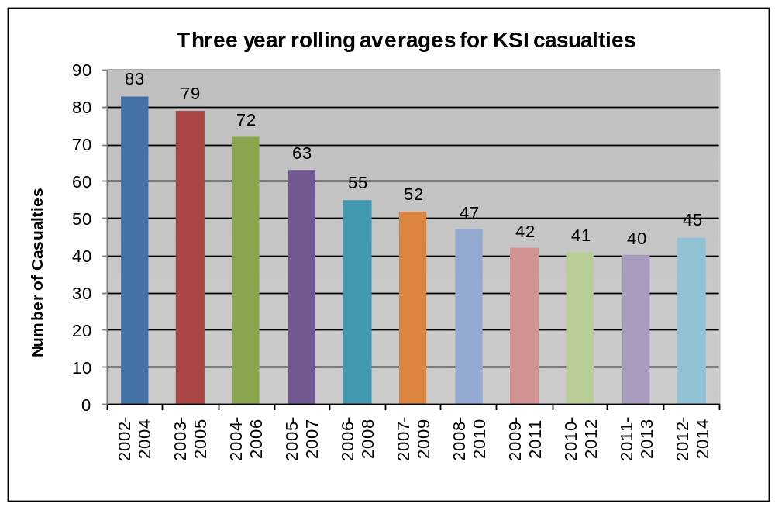

This target has not yet been met though additional road safety measures being introduced will certainly help to achieve the target and the borough is on course to achieve this target

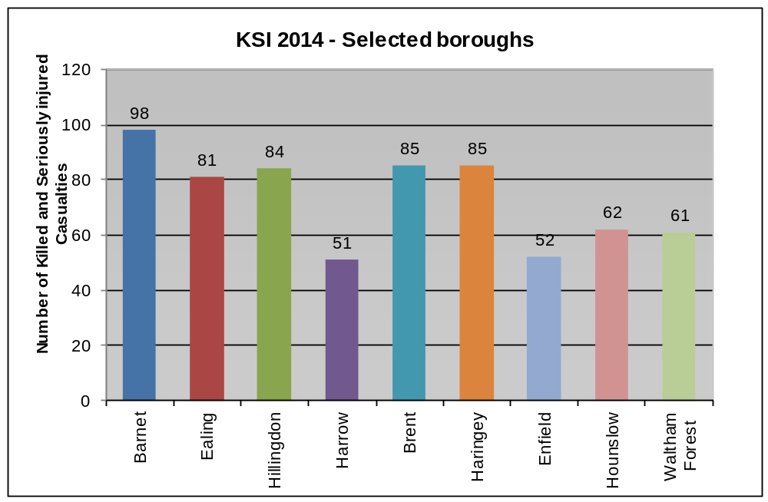

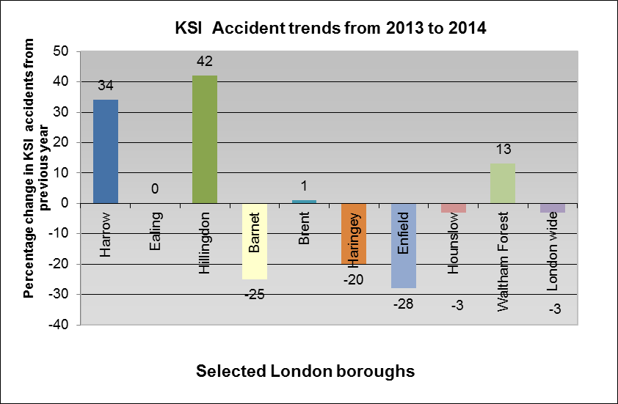

4.2 Total casualties

This is a locally agreed indicator and target and is particularly important for considering local clusters and trends because the level of killed and seriously injured accidents in the borough is relatively low.

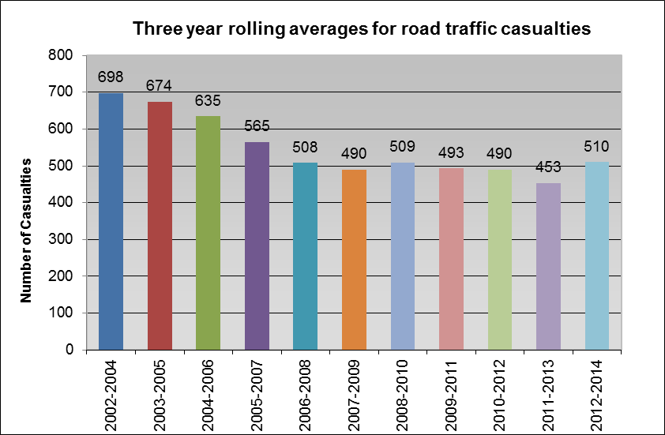

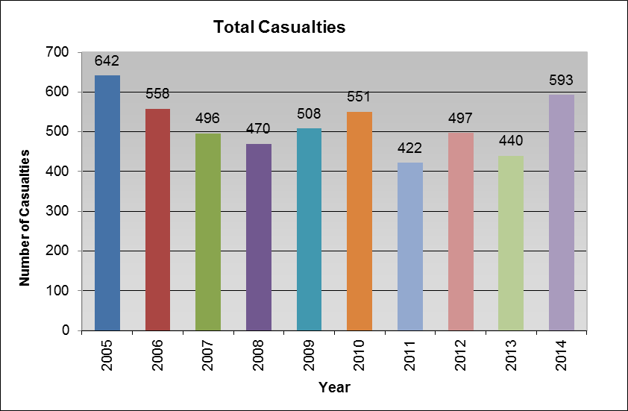

Harrow is concerned about this recent rise in road casualties and through measures outlined in this plan still considers the target to be achievable. In addition, the borough is committed to reducing casualties to below 431 in the longer term. The target average for 2015-17 is 450.

4.3 Motorcycle casualties

This is a locally agreed target and was selected because the borough is particularly concerned about the level of motorcycle casualties. The increase in the use of motorcycles and scooters and their popularity as a means of relatively affordable independent transport has led to an increase in casualty numbers over the last few years. In Harrow motorbikes and scooters make up about 1% of all traffic but casualties associated with them account for just over 10%.

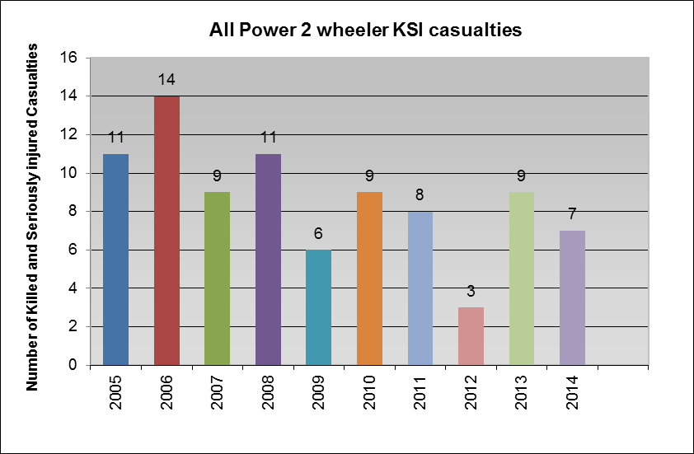

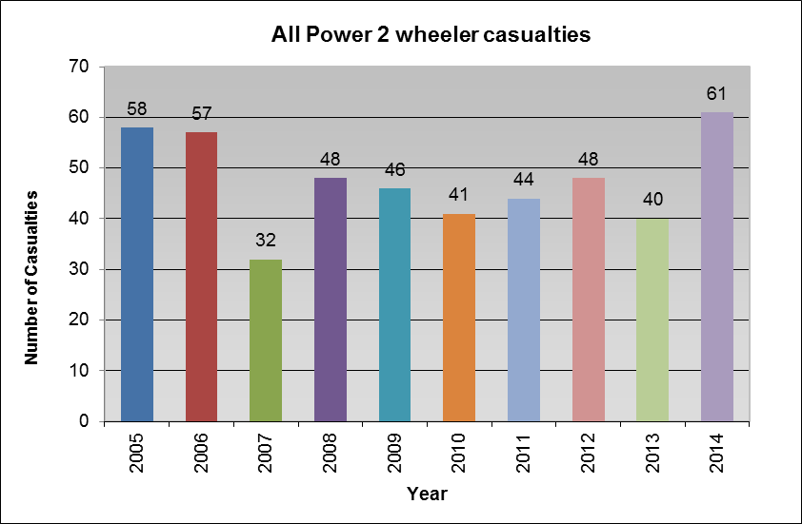

This target was met in 2010 however this has increased recently. Reducing motorcycle casualties in the borough is one of Harrow transport’s primary objectives and additional campaigns will be required to address motorcycle safety. TfL launched its own motorcycle action plan for London in 2013 see link below.

https://tfl.gov.uk/cdn/static/cms/documents/motorcycle-safety-action-plan.pdf

5. TRENDS IN CASUALTIES

There are many subgroups of people that contribute to the overall casualty data that need to be considered in order to make sure that Harrow is taking the right steps in trying to reduce the number of casualties.

Subgroups where trends in casualties are monitored are shown below along with the reason for these trends being monitored.

Harrow groups and subgroups | Reason
Killed or seriously injured young people | The borough is continually trying to increase the number of people walking and cycling to school, it is important to be sure that there is no knock on impact of an increase in associated young people killed or seriously injured.
Young pedestrians killed or seriously injured | As above
Young pedestrian casualties | As above
Young cyclist casualties | The borough is making considerable efforts to increase the number of people cycling. Young people will be a key group that will be targeted to achieve an increase. Therefore it is important that if there is any increase in cycle accidents it is immediately addressed.
All killed or seriously injured accidents | There has been a recent increase in KSI accidents within the borough this may Although accidents are random events, many commonly occurring factors are shared in accidents and it is the identification of these factors, which lead to the development of engineering remedial measures.  It is not possible to eradicate the failings of driver behaviour through engineering measures; however, the alteration of the highway layout can minimise certain types of conflicts occurring and lead to a reduction in the frequency of traffic accidents and reduce the severity of injuries. Engineering measures are therefore developed exclusively on that basis.  Additional investment in road safety education and road safety measures would ensure the significant casualty reductions achieved are maintained and further road safety benefits can be accrued.
Pedestrians killed or seriously injured | Pedestrians are a particularly vulnerable user group and for this reason, the borough considers it important to closely monitor these accidents.
Cyclists killed or seriously injured | As above and also as an increase in those cycling is anticipated it is important that this group is particularly closely monitored.

5.1 Children (0-15yrs)

It is a borough objective to encourage children to walk and cycle to school. This is for personal health reasons and is a good way to reduce child obesity, but reducing the school run would also reduce the associated local congestion and improve the local air quality. The borough has been successful in doing this and reducing the numbers going to school by car. However it is a careful balance to ensure that children and young people while walking and cycling are safe and that the consequence is not an increase in casualties.

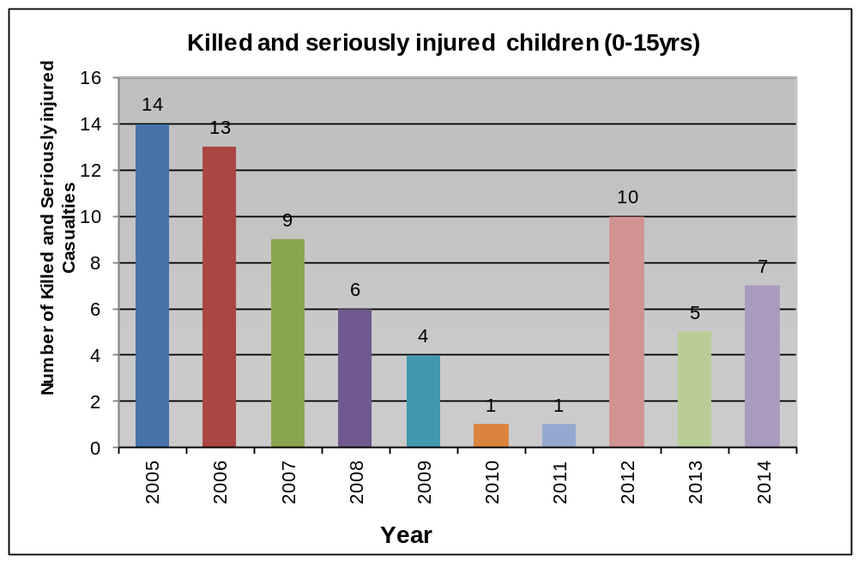

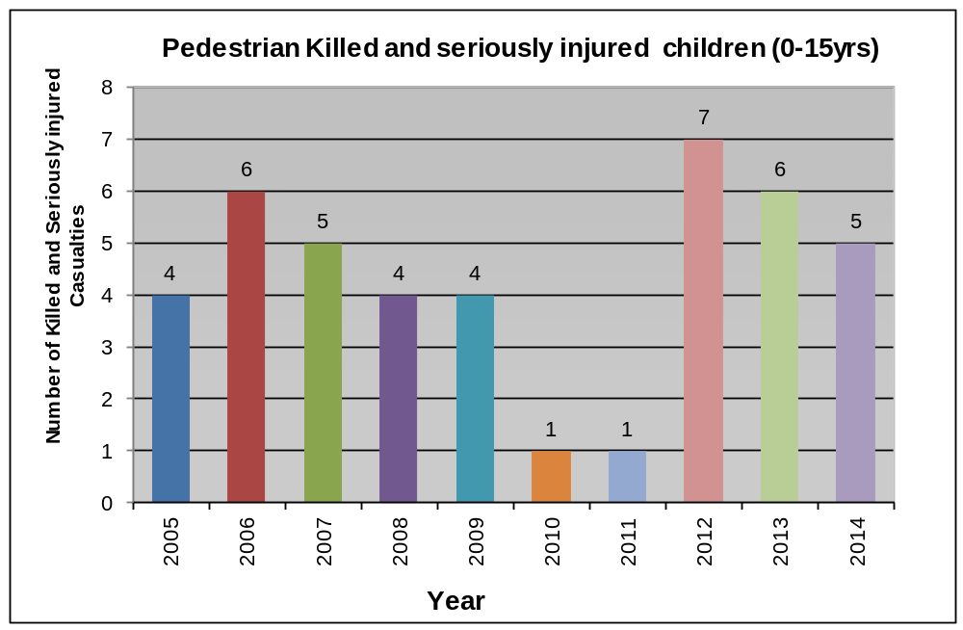

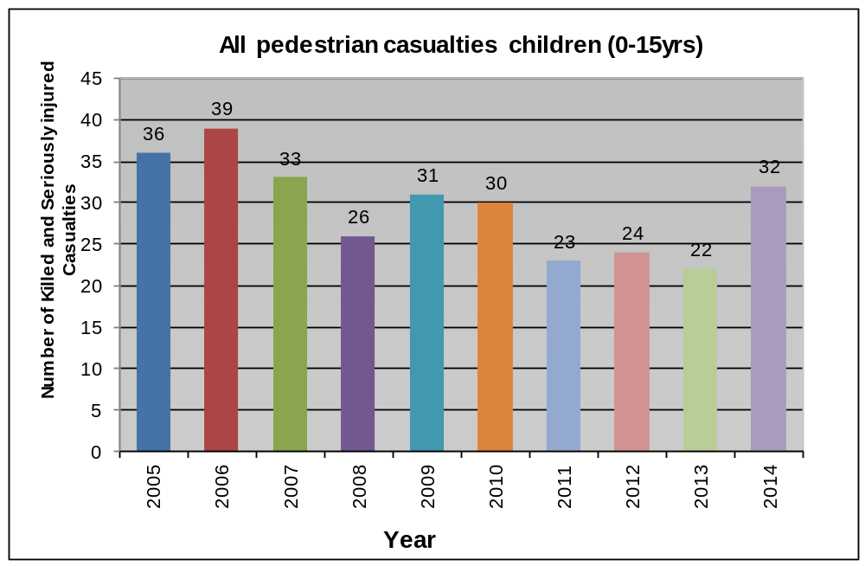

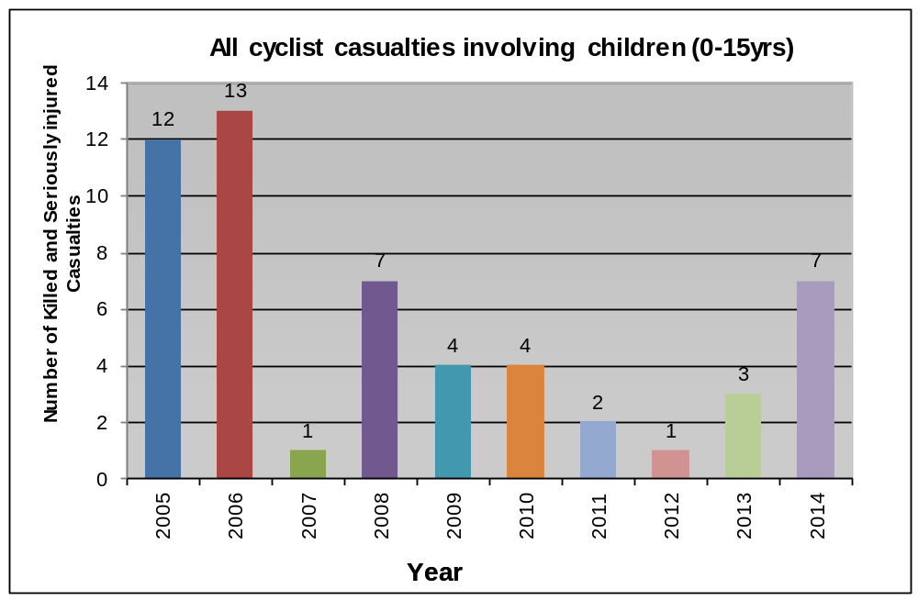

5.2 Pedestrians and cyclists

Pedestrians and cyclists are particularly vulnerable on the roads and therefore Harrow considers trends in accidents for these groups particularly carefully. A seemingly minor accident involving a car could cause a serious injury when a pedestrian or cyclist is involved.

Although the number of cyclists killed or seriously injured on Harrow roads is relatively low, the borough is anticipating a high increase in the numbers cycling over the following few years and is aware of the need to ensure that maximum attention is given to ensuring an increase in accidents does not occur as a result.

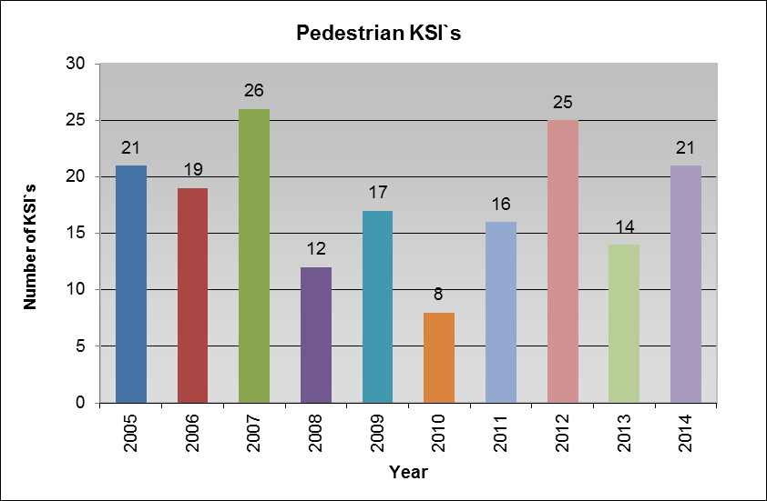

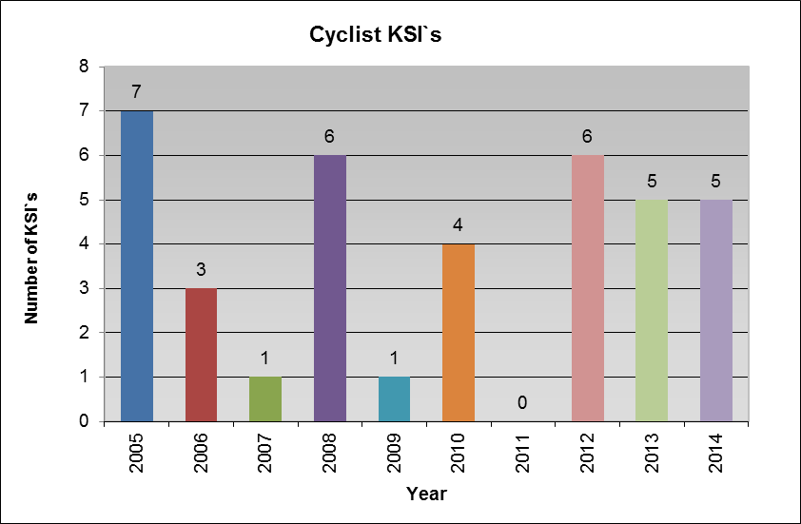

6. EDUCATION, ENGINEERING AND ENFORCEMENT

The major causes of accidents in Harrow are:

- Careless driving (including driver distractions such as mobile phones and disruptive passengers)
- Speed
- Dangerous driving (including driving under the influence of alcohol or drugs)

To address these problems, Harrow uses the following tools:

- Education through public information (campaigns and leafleting on road safety issues) and providing public information direct to school age children
- Engineering through highway management
- Enforcement through parking attendants and speed and red light cameras

Initiatives such as introducing 20 mph Zones, School Travel Plans, Local Safety Schemes and major scheme works all aim to reduce casualties. In particular, Harrow’s 20mph programme focuses on areas surrounding local schools.

Harrow has adopted a comprehensive programme of Education, Training, Engineering and Enforcement aimed at reaching Harrow’s targets for casualty reduction and further reducing accidents.

6.1 Education and Training

In order to ensure that education is targeted at the appropriate groups it is necessary first to know who is involved in accidents in Harrow and what type of vehicles are involved.

Accident analysis carried out by TfL show that in London boys aged 11-14 are most at risk from being hit by a vehicle when crossing roads. Children from low income and ethnic minority backgrounds are also particularly vulnerable. Approximately a quarter of all teenage pedestrian casualties occur on the way to or from school. Peer group pressure, mobile phones, texting and the use of personal stereos can easily distract young road users. Other activities including ball games, rollerblading and skateboarding on the street can also lead to serious accidents involving teenagers and traffic.

Recent research by TfL also influences the way road safety education is implemented in the borough. In particular they have recently conducted road safety research projects into:
- Surveying attitudes on seatbelt wearing and use of hand-held mobile phones; and
- Quantifying ethnic inequalities in road traffic injury amongst London's black and Asian minority ethnic groups.

The following charts show the types of vehicles involved in all accidents in Harrow in 2014, the age group of those involved, the gender of those killed or seriously injured and also the ethnicity of child pedestrian casualties. These charts show the need to target education and training particularly towards young people, pedestrians and more particularly child pedestrians from ethnic minorities.

Harrow has a larger proportion of ethnic population compared with Greater London and this is reflected in the Borough’s higher ethnic casualty figures. This can only be reduced by further education and publicity. It is intended to pursue this avenue by working with local community groups and schools, ensuring that education measures in appropriate languages are understood by their target groups, and that the information is effectively distributed amongst these groups. In addition, Harrow monitors the ethnic backgrounds of applicants for child cycle training to ensure that ethnic minority children do receive cycle training.

Gender
Gender is the most significant factor in casualties and in the numbers killed or seriously injured as shown by the following graph:

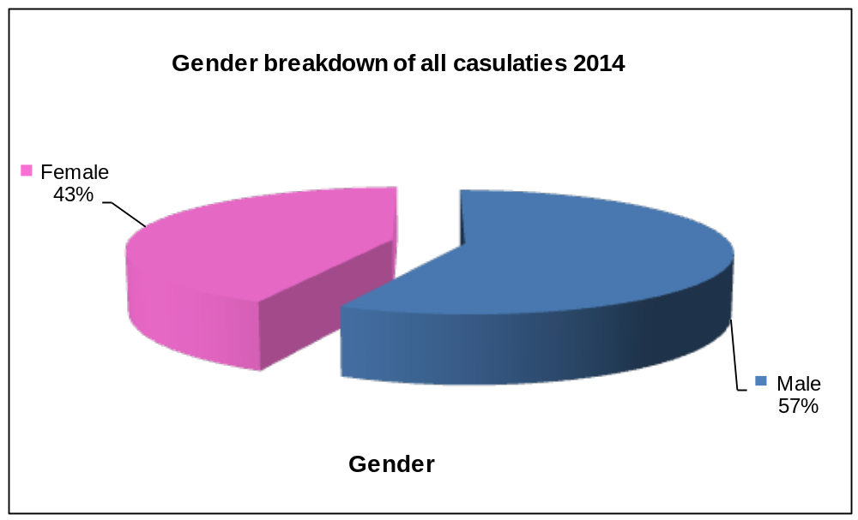

Road user class
When considering the volume of all road user types, the chart below shows the extreme vulnerability of pedestrians, cyclists and motorcyclists on the roads.

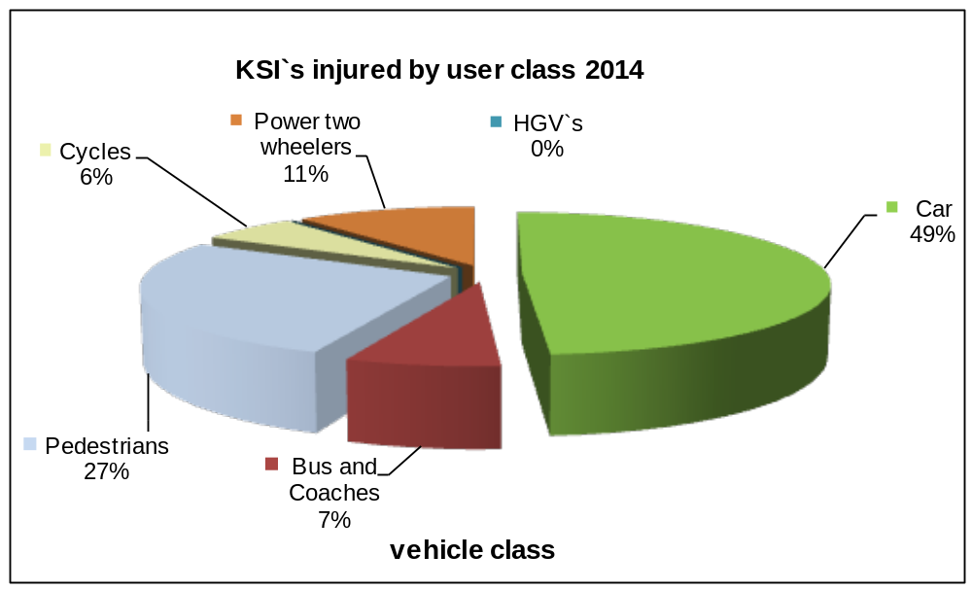

Age
Considering that 16-24 year olds do not make up 25% of the population, the following chart is very revealing as to how we need to direct our educational and promotional resources.

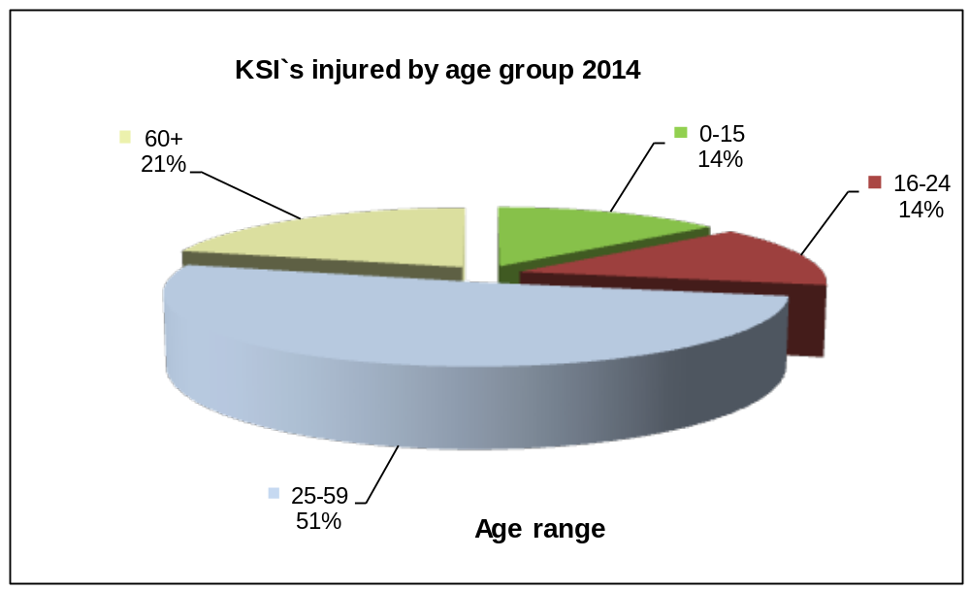

Ethnicity

Harrow is a diverse borough, having 63.8% of its population from the BME (Black and Minority Ethnic) communities, with the largest group being of Indian ethnicity (specifically those from Gujarat and South India). The borough can also claim to have the largest concentration of Sri Lankan Tamils in the UK and Ireland as well as having the highest density of Gujarati Hindus in the UK This is monitored because there has been national evidence showing that black and ethnic minorities are higher represented in child pedestrians than any other groups.

In 2014 20% of child pedestrian casualties recorded in Harrow were from ethnic minorities. This figure is likely however to be significantly higher bearing in mind that a large proportion of reported accidents did not record the ethnicity of the casualty.

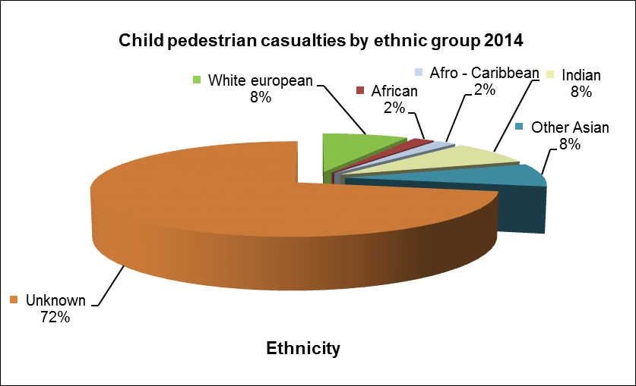

6.1.1 Road Safety Resources

Harrow employs one Senior Road Safety Officer and two dedicated Travel Planners. The Senior Road Safety Officer is responsible for developing education, publicity, training and initiatives for all road users, including the delivery of cycle training and managing the School Crossing Patrol Service. The Travel Planners assist the schools in the development of School Travel Plans and work with Businesses to reduce the reliance of the motor car. Further information on School Travel Plans is provided in Harrow’s School Travel Plan Strategy. School crossing patrols are currently managed by the Senior Road Safety Officer however schools are being encouraged to pay directly for this resource in the future.

6.1.2 Road Safety Education

The following is a summary of all road safety initiatives undertaken by Harrow’s Senior Road Safety Officer:

6.1.2.1 Pre School Road Users

Through links with Transport for London and the local Primary Care Trust, invitations to join the Children’s Traffic Club are sent to parents of children just before their 3rd birthday. Following registration, three interactive DVDs with activity books, parent guides and stickers are sent out at four month intervals to assist parents in giving their children basic road safety instruction. Downloadable colouring sheets are also available on the Children’s Traffic Club website. Additional materials are provided to playgroup and nursery leaders to compliment the Traffic Club information and to promote membership of the club to as many parents as possible.
he overall uptake of the Children’s Traffic Club from April 2014 to March 2015 was 2,782, an increase of 340 in comparison with the previous financial year’s uptake as shown below in the uptake comparison:
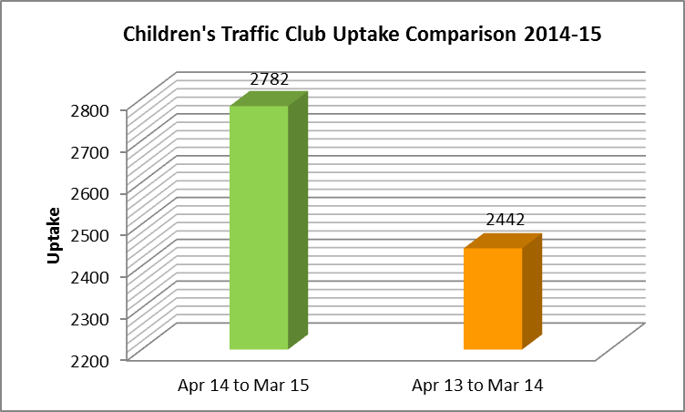

The majority of Children’s Traffic Club registrations have come through working in partnership with nurseries. The 2nd most popular registration route has been through other promotions.

Summary of registration source

Registration by source
Nurseries | PCT | Other
2,744 | 0 | *38

*Other promotions represent those registrations achieved through the distribution of support materials to individual boroughs and online via the website.

Visits to nurseries and playgroups are made by the Senior Road Safety Officer on request from nursery leaders but are limited by staff resources. The intention is for the Senior Road Safety Officer to make contact with playgroups on an annual basis to promote and discuss road safety issues.

Where appropriate, Department for Transport road safety leaflets translated into Bengali, Urdu, Punjabi and Gujarati will be distributed at these meetings. On-going discussions with playgroup and nursery group staff will be made to see whether other translations are required and would be of value.

6.1.2.2 Road Safety Presentations and Practical Pedestrian Training

The Council is working with schools to deliver road safety presentations and practical pedestrian training annually. Each school is assessed individually to establish their viability in terms of school curriculum time and the willingness of school staff and parents to support the initiatives during delivery. Both initiatives are designed to encourage behaviour change and ultimately, reduce the number of child casualties of all severity associated with journeys to and from school.

Due to staff resources, both initiatives are commissioned to ensure delivery to 60% of all primary school pupils at the very minimum. Tailored road safety presentations are delivered to all pupils from Year 1 to Year 6. Practical pedestrian training is delivered only to Year 4 pupils as less staff resources are required to support the training.
Practical Pedestrian Training is designed to raise child observation and awareness skills whilst crossing the road with an adult as well as equipping them with road safety skills in preparation for independent travel. This intervention is commissioned and offered to all primary schools on a first come first served basis.
Road safety presentations are delivered to primary schools in the Borough with aims of educating children about the dangers encountered travelling to and from school, outside of school and provide them with the knowledge to make rational, informed decisions as a pedestrian Age specific presentations target all year groups and are supported with additional publicity and promotional material. Presentations cover all aspects of road safety from pedestrian safety, distractions, in car safety, cycling and use of public transport.

6.1.2.3 School Crossing Patrol

The Council actively promotes walking and cycling in the borough and are working with schools to encourage their parents and carers to consider walking, cycling or using public transport on their journey's to and from school. The aim of this programme is to ease congestion at the busiest times of the day and to encourage Harrow’s residents to become fitter and healthier. School crossing patrols operate at certain places where it can be or difficult to cross the road when walking to and from school. This is not necessarily outside a school, but could be anywhere identified as a direct route to a school.

Across the borough we have 12 established school crossing patrol sites. Like other authorities we have to follow strict national criteria for the safety of school crossing patrol operators and the members of the public using the site. The site assessment, takes into account the number of pupils crossing, the volume and speed of traffic and any special site characteristics.

We constantly review all the sites, and the process established, to identify and approve new sites. We also disestablish sites that no longer meet the criteria

As part of the medium term finance strategy the School Crossing Patrol Service is seeking to achieve cost neutrality. We are consulting with the existing 12 schools which currently have School Crossing Patrol sites to establish how this will be achieved.
School crossing patrols are provided to schools in the borough where they can be of most assistance. This support is limited by the number of patrols available but the support offered is prioritised on achievable safety benefits. All School Crossing Patrol sites are risk assessed annually.

6.1.2.4 Walking Buses
A walking bus is an organised group of children who walk to school together accompanied by designated adults who are usually parents of some of the children walking or school teachers. Several schools have shown interest in supporting this low cost approach to travel planning. This initiative contributes to car usage reduction and in turn can assist in the alleviation of congestion outside schools. At present there are currently 5 walking bus routes running and more are in the process of starting up.
The Senior Road Safety Officer conducts safety audits on proposed routes and ensures that required training is given to supervisors and participants. Publicity for the schemes is also being included in school newsletters and information leaflets are being made available to playgroups, nurseries and schools for distribution to the new intake of pupils. These measures do rely on the co-operation of parents, which can sometimes be challenging to sustain.

6.1.2.5 Theatre in Education

A range of plays are commissioned and offered to schools on a regular basis and aimed at various age groups. The plays include themes relevant to junior and high schools. The plays encourage the children to interact with the actors to reinforce the road safety messages.

6.1.2.6 Junior Travel Ambassador Scheme

The JTA scheme will be promoted to all primary schools at the start of the academic year. It encourages peer-to-peer engagement and will give schools all the resources and guidance they need to promote safer, active and independent travel within the school community. Schools are encouraged to appoint JTAs to lead on promoting road safety and sustainable travel in schools.

6.1.2.7 Youth Travel Ambassador Scheme

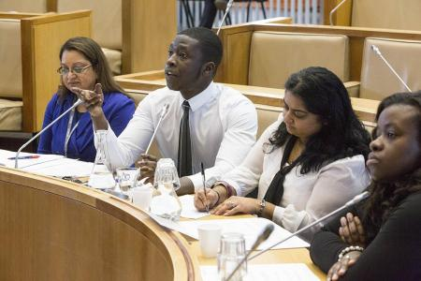
Youth Travel Ambassadors (YTA) is a youth-led education project launched at the start of the academic year. 6 secondary schools have appointed YTAs to make a difference to the travel and transport issues which affect them and their community.
Teams of young people are supported through the YTA programme to create their own bespoke educational campaigns. The YTA teams then attend a Dragons Den style pitching event to present their ideas to the panel. The panel will offer advice, support and funding to enable the teams to make their ideas a reality.

6.1.2.8 School Parking Problems

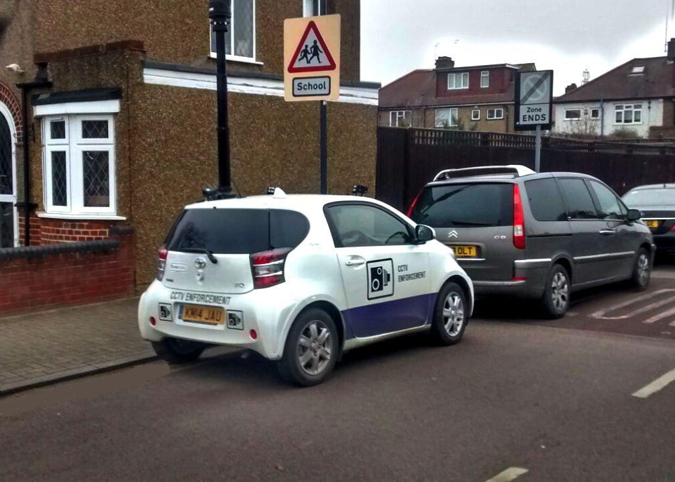
Parking on school keep clear markings prevents children and adults from being seen as they are obscured by parked vehicles when they cross the road outside their school. Every weekday motorists are putting children and others at risk by inconsiderately parking or waiting on these markings during school drop off and pick up times.

The Senior Road Safety Officer and Travel planners work closely with Parking Enforcement officers and local Police. A combination of education and enforcement is used to deter motorists who persistently commit parking contraventions or park inconsiderately outside the school vicinity and local residents near schools.

A robust system has been implemented to identify what schools have parking issues, understand the type of issues identified and effectively enforce parking.

Publicity information will be included as a regular feature in newsletters issued to pupils and parents and as a review item in School Travel Plans. Posters and other promotional materials supporting local, London and national campaigns will also be issued as suitable materials become available. This will normal contain information about illegal parking, available in various languages. The council has three dedicated state of the art CCTV enforcement vehicles that regular visit school to carry out enforcement of the waiting restrictions.

6.1.2.9 Cycle Proficiency and Promotion

Bikeability training at levels 1 and 2 is offered to all primary schools’ Year 5 and 6 pupils. Level 1, 2 and 3 courses are offered to all secondary schools in the borough of Harrow. It is also during half terms and school holidays.

There are three levels of Bikeability cycle training:

- Level 1: Basic cycle skills
Delivered entirely off-road, level 1 classes are the ideal ‘next step’ for children who have learned to pedal independently. The 2-hour class focuses on steering and control, starting and stopping, signalling and looking back.

- Level 2: Starting on-road cycling
Delivered on Harrow’s quieter, residential roads, level 2 focuses on safely managing junctions and riding alongside traffic. This 4-day course is ideal for pupils aged 10+ who perhaps did not pass the level 2 course at school, or were unable to take part.

- Level 3: Advanced on-road cycling
Ideal for the keen cyclist who may be slightly more experienced or slightly older, the level 3 course spends 4 days learning how to cycle safely through larger junctions, on busier roads, use cycling infrastructure effectively and plan a safe and efficient journey.

Adult cycle training is delivered to all adults who live, work or study in Harrow. Classes are available for complete beginners who want to learn to cycle, those wishing to improve their control and basic skills, cyclists who want to start riding on the roads, and aspiring cycle-commuters. Adult and family rides are also delivered for families who wish to take up a cycle proficiency course together. Classes run on alternate Saturday mornings. Bikes are available to hire for £10.

Cycle training is delivered by our contracted provider, Cycle Experience. The Senior Road Safety Officer and Travel Advisors promote cycle training initiatives and support course provision at schools. During programmed road safety visits, the promotion of cycle training and cycling to school will be used to the appropriate age groups. In order to promote cycling to school, secure cycle parking provision will be surveyed and where possible supplied to schools through funding from the development of School Travel Plan initiatives.

The graph below indicates the amount of pupils that received cycle training in the financial year 2014-15:
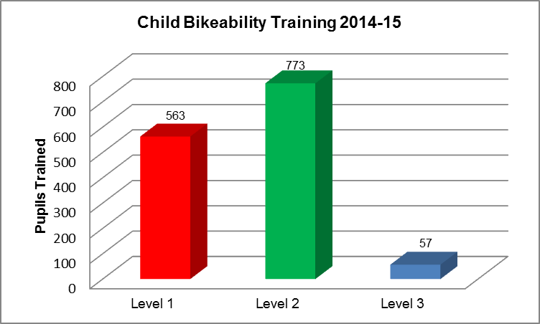

There is a distinctive increase in level 2 training with over 50% of pupils achieving this bikeability level. Training levels for bikeability level 3 are considerably low with just 4% of pupils trained. However it must be taken into account that level 3 training excludes primary school pupils and can only be delivered to secondary students and adults. With just 12 secondary schools in the borough this serves as a contributing factor.

The graph below highlights the cycle training volumes for adults in the financial year 2014-15:

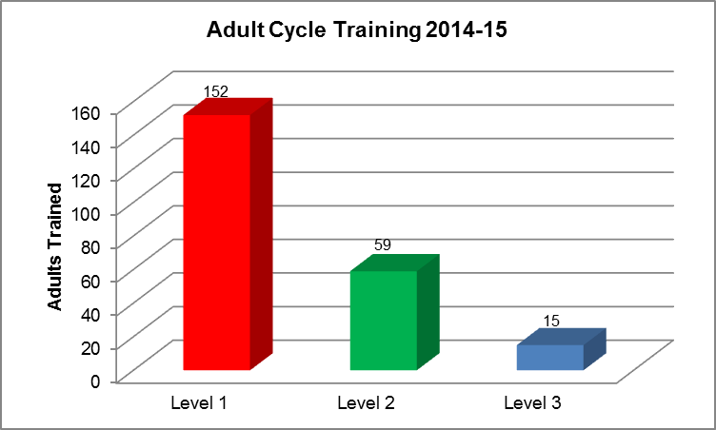

There is a distinct decline of training numbers as the bikeability levels increase. 67% of adults have undertaken bikeability level 1 which suggests a large proportion of adults are either complete beginners or have basic/ limited cycling skills, with aims of developing further. In comparison with just over 6% of adults achieving bikeability level 3, this affirms the identified trend.

Bikeability Targets 2015-16 – Children and Adults

Bikeability Targets 2015-16
Bikeability Level | Children | Adults
Level 1 | 591 | 160
Level 2 | 812 | 62
Level 3 | 60 | 18

6.1.2.10 Women’s Beginners and Commuter Bike Clubs

The Harrow Women’s Bike Club is a space for beginner cyclists to learn to ride, improve their cycling skills, get advice from trained instructors, get support from new friends, and improve their fitness. This club was launched as a trial in February 2014, with aims of teaching complete beginners to ride in a comfortable environment, helping women gain the confidence to eventually start cycling in parks and on the road. Through this they will achieve level 1 bikeability outcomes. With increasing demand for bookings, the club has now been fixed as part of a permanent cycling initiative.

The Harrow Women’s Commuter Club essentially is the graduation from the beginners club where women can achieve level 2 bikeability outcomes. Trained instructors will lead a bike ride around the borough, exploring cycle routes around Harrow, teaching members how to cycle safely on the roads, and providing an opportunity to build fitness and confidence as cycle commuters. Rides vary in length and difficulty, to cater for both new and experienced commuter cyclists. The club runs for 6 months annually, once a week in the evenings from 6.30pm. Bikes are provided free of charge.

6.1.2.11 Learn to Balance and Ride Sessions

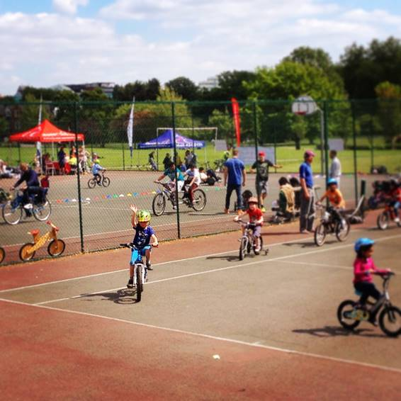
The ‘Learn to Balance and Ride’ bike club is aimed at children aged 3-14 who cannot cycle without stabilisers. Instructors work with children to develop their balancing skills before introducing pedals, enabling them to develop the fundamental skills entailed in level 1 bikeability.

These cycling classes have been tailored to be inclusive for all children and instructors will be able to give children extra focus where required, particularly for children diagnosed with dyspraxia, autism and downs syndrome.

Initially the club was launched in February 2014 on a trial basis. With the growing popularity and recognition of young children rapidly attaining core cycling skills from a young age, this club has now been considered a core cycling initiative which will continue to be delivered.

The bike club runs twice a week after 4.10pm. Bikes are provided free of charge

6.1.2.12 Bike It Plus Programme

The ‘Bike It Plus’ programme aims to increase levels of cycling to school through tailored assistances and activities to meet each school’s needs, creating a pro-cycling culture. The appointed Bike It officer engages with 5 primary schools and 1 secondary school to develop stronger links for continued cycling in the transition from primary to secondary school and beyond.

The Bike It Officer will liaise with the borough officer to ensure schools remain intensively engaged in the programme provide support where required. Schools can only be eligible for enrolment on the Bike It programme on the basis that they either have an active travel plan or are currently in the process of developing one.

In the academic year 2014-15, 5 primary schools and 1 secondary school were appointed in the Bike It Programme: Nower Hill, Newton Farm, St John Fisher, Vaughan, St Anselm’s and Norbury. Throughout the year these schools have consistently and intensively engaged in numerous cycling initiatives tailored by the Bike it officer and have agreed to remain in the programme until 2016-17.

For the academic year 2015-16 the following schools have been targeted to be included in the programme: Belmont, Aylward, Priestmead, St Joseph’s RC, Krishna Avanti, Stanburn and Camrose. Of these 7 schools, 5 will be shortlisted for enrolment. The shortlisting process includes meeting with the school to assess their commitment to the programme. This process will commence at the start of school term in September 2015.

6.1.2.13 Ethnic minorities

The council will distribute the Department for Transport (DfT) road safety leaflets, where available in Bengali, Urdu, Punjabi and Gujarati. The DfT leaflets provide background road safety information to parents of children aged up to 6 years and are supported by nursery and playgroup staff.
Road Safety presentations are delivered to community groups where requested by other service areas to educate basic road safety and safer crossing facilities. Presentations are commonly requested through Community and Cultural services.

6.1.2.14 Young Motorists

Targeted at year 12 and 13 students, Safe Drive Stay Alive (SDSA) is a powerful full stage production aiming to reduce the number of road casualties among young road users and educate them about the risks, be able to identify the common causes for crashes and prevention strategies.

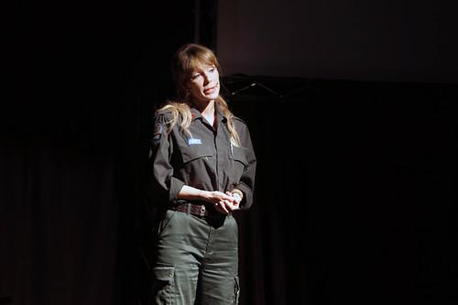
This production consists of a filmed reconstruction of a crash and interspersed at relevant points by a police officer, a paramedic and fire-fighters who come on stage to give an account of their personal experiences of accidents. It also features speakers whose lives have been permanently changed; a bereaved family member and a seriously injured survivor. They speak from personal experience and explain how bad decisions can take seconds to make but the impact can last a lifetime.

SDSA addresses the following key road safety messages:

- Peer Pressure
- Excessive Speed
- Seatbelts
- Drink & Drug Driving
- Driver Distractions (i.e. mobile phones)

In the academic year 2014-15, SDSA was delivered to a total of 7 6th forms/colleges with 525 pupils attending from Harrow. With this being the first year of SDSA delivered in Harrow, we aim to continue promoting the programme with aims of increasing the amount of schools attending from Harrow and Brent.

The delivery of SDSA is followed up with the distribution of First Car Magazine magazines which are targeted at young drivers. Sponsored by over 14 London Boroughs, the magazines are distributed to 6th forms and colleges in Harrow.

The use of moped and motorcycles (powered two wheelers) by teenage riders is causing concern in the borough. High profile motorcycle safety campaigns focussing on young riders have been run during the summer months and will continue to be run to address the high number of motorcycle casualties.

6.1.2.15 Freight / bicycle awareness and safety issues

There is a lot of concern about the increase in accidents between freight vehicles and cyclists. Around half of all cycle deaths in the Capital involve a goods vehicle. To date, none of these have occurred in Harrow. However, it is a concern that must be continually addressed.
To help tackle this issue, the Mayor and TfL are:
- Introducing new 'Safer London Driving' cycle awareness training for lorry drivers, which is now part of the HGV drivers' Certificate of Professional competence accredited ;
- Calling for more freight operators to join the Freight Operator Recognition Scheme (FORS) and are offering 540 free 'Safer London Driving' places to FORS members;
- Urging cyclists not to undertake lorries at junctions through a widespread cycle safety advertising campaign which will see hundreds of safety posters go up at key sites throughout the Capital;

In addition to the cycle safety awareness training developed for HGV drivers, TfL has also distributed more than 20,000 cycle safety lenses (known as Fresnel lenses) to freight companies operating in London and contacted 300 operators that have construction vehicles in their fleet, urging them to install side-bars or other safety devices on HGVs that are currently exempt.
In Harrow, any freight operator using vehicles over 7.5 tonnes will be sent an information package regarding cycle safety. This includes information explaining the dangers to cyclists regarding freight vehicles. Also included is a lorry sticker for placing on the back of the lorry warning cyclists not to undertake lorries on the inside lane. Harrow will be developing a specific programme for lorry drivers to be included as part of FORS. Lamp post banners will be erected encouraging cyclists to stay further away from lorries. These will be introduced at selected locations where lorries regularly make left turns.
All Harrow Council drivers are encouraged to undergo a certificate of competency training which includes the TfL course on cycle awareness. This ensures that they are fully aware of the risk faced by cyclists when approaching their vehicles.

There are 15 FROS accredited freight organisations in Harrow including the London Borough of Harrow. FORS accreditation level for each freight organisation is shown below:

FORS Accreditation Status
Company | FORS ID | FORS Status | Business Sector
Brian Doogue Haulage Ltd | 001144 | Gold | Construction, General haulage
London Borough of Harrow | 001238 | Gold | Local authority / public sector
ASME Engineering Ltd | 002627 | Silver | Construction and Metals
Chinnadurai | 006488 | Bronze | General haulage
PL Logistics Ltd | 003004 | Bronze | Construction
CD Plant Hire and Repairs | 006293 | Bronze | Plant hire
P Deehan Haulage | 003004 | Bronze | Plant hire, Specialist haulage
Nexus Logistics | 005382 | Bronze | Parcels and courier services
KCM Haulage Ltd | 001833 | Bronze | General haulage
Edmundson Electrical (Harrow) | 001239-13 | Bronze | Electrical
Harrow Community Transport | 002272 | Bronze | Bus and coach (passenger)
JP Sweeney | 001872 | Bronze | Construction
M.Musgrove Ltd | 007414 | Registered | Manufacturing
Boundary Fencing Contractors Ltd | 002526 | Bronze | Construction
Novus Automotive | A00092 | Associate | Auto Parts

6.1.2.16 Road Safety Campaigns

The council is committed to making the roads of Harrow safer for everybody. Harrow is already one of the safest London boroughs as far as road casualty numbers are concerned but there is always room for improvement. Throughout the year, several road safety campaigns take place aimed at a variety of different groups.

Motorcycle Safety

Harrow’s motorcycle campaigns are aimed at improving road safety for motorcyclists and include the following:

- Large lamppost banners displayed along locations where there is a history of motorbike accidents

- Posters and information leaflets sent out to all high schools, colleges, businesses, motorcycle retailers and other areas where there are a large number of motorbike and scooter riders.
- Promotion of London wide schemes such as “BikeSafe” and “Scooter Safe” through motorcycle dealers and related industries, 6th forms/colleges

Cycling Safety

As part of a bid to increase the visibility of cycling in Harrow and promote cycling safety, cycling campaigns are organised by the Senior Road Safety Officer in the following methods:

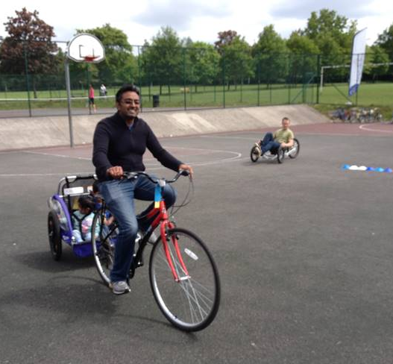
- Posters and information leaflets on community noticeboards, lamp columns, schools, GP surgeries, Harrow People magazine, Harrow’s official website and Northwick Park Hospital, promoting free cycle training courses, HGV and cyclist safety awareness.

- ‘Try Cycling’ loan schemes are run on an ad-hoc basis to encourage people to loan a bike of their choice and try cycling over a 4 week period.

- An annual week-long cycling roadshow combined with various cycling activities for adults and children known as the ‘Tour de Harrow’. This is launched during the same time as ‘Bike Week’ – a celebration and promotion of all the benefits about bikes and cycling which falls in June.

- Large lamppost banners displayed along locations where there is a history of cycling accidents.

Motoring Safety

Where identified, Harrow runs targeted campaigns with aims of improving motorist behaviour and addresses the key road safety messages where relevant. These are as follows:

- To educate motorists about the dangers of drink and drug driving, campaigns are launched during festive periods and major sports events such as the UEFA World Cup and Euro football competitions.

- A ‘Clear your windscreen’ campaign is publicised in the winter to highlight the danger of driving with a frosty windscreen.

- Raise awareness with speeding, seatbelts, child car seats, mobile phones and vehicle insurance. Other aspects covered include vehicle safety checks (i.e. tyres), tiredness and fatigue, in-car safety and emergency procedures.

- Providing relevant literature and for young and elderly motorists addressing the common factors developing accident prevention strategies.

Subject to funding and prioritisation, posters and information leaflets are distributed on the above issues.

6.2 Engineering

In addition to training and educating people to use roads safely, it is important to ensure as far as practicable that the Borough’s roads are laid out and managed in a way that minimises the risk of accidents. In this respect, road safety schemes fall into two main categories: accident reduction and accident prevention.

6.2.1 Accident reduction
Details of all personal injury accidents reported by the Police are collated by the London Accident Analysis Unit of Transport for London (TfL). Details of all accidents in this Borough are then passed to Harrow Council for monitoring and analysis.
All fatal incident sites are fully investigated by the Police and their findings are shared with representatives from the council usually at an onsite meeting to establish if there were any factors which could be mitigated by either engineering and educational means.
Remedial measures are then designed to reduce the number of accidents. Accidents are analysed to identify clusters of accidents, accident patterns and common causation factors. Accident rates are compared with surrounding boroughs and London averages to help identify where action might be most beneficial. Cost benefit analysis is also undertaken to maximise the benefits in terms of casualty reduction that can be achieved with the available resources.

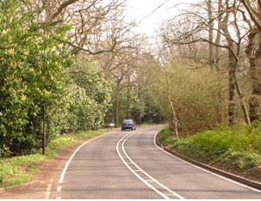
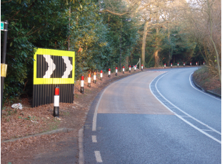

Old Redding scheme – accidents reduced 65% after measures introduced on the right
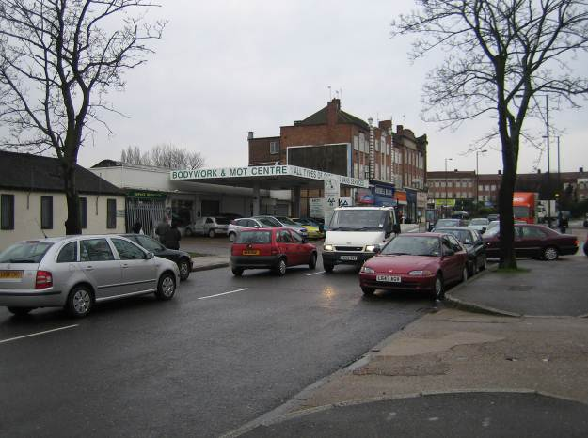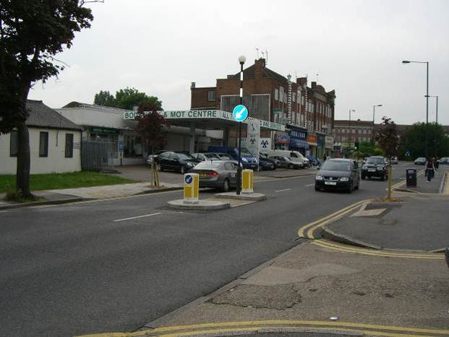
Kenton Lane – Before measures Kenton Lane – After measures introduced
Currently the councils priority is to tackle roads in the borough where killed or serious accidents involving personal injury (KSI)`s have been recorded. This is in line with the Mayor for London’s Road safety strategy to target KSI personal injury accidents.
Harrow has programmes for implementing 20mph zones and local safety schemes throughout the borough.

6.2.2 Accident Prevention
Prevention is better than cure. Safety aspects of new traffic proposals are of paramount importance. Care must be taken to avoid the repetition of previously identified problems, or the creation of new conflicts or hazards. This is addressed by ensuring all new schemes have a design risk assessment carried out by an experienced and independent safety audit Engineer at various stages of the scheme development.

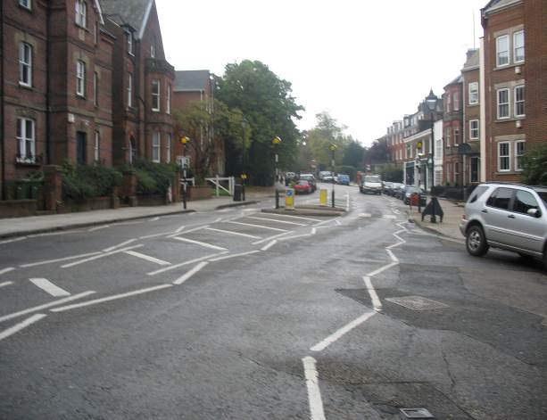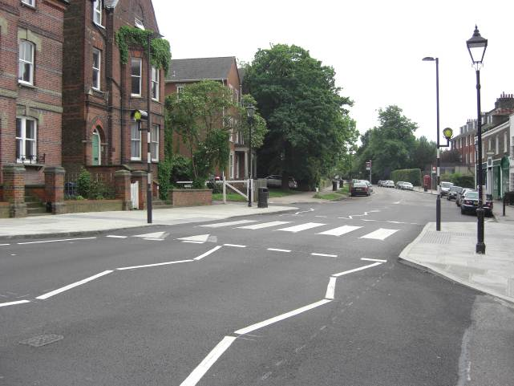
Harrow-on-the Hill – Before measures Harrow-on-the Hill – After measures

6.2.3 20 mph zones
Reducing speeds in and around local schools is a priority for the Council. There is a high level of public concern about the speed of vehicles and the council is working closely with the Police and the public to address the issue. The Council is concerned, not only for the number of casualties caused by excessive speed but also for the detrimental affect it has on the environment and quality of life.

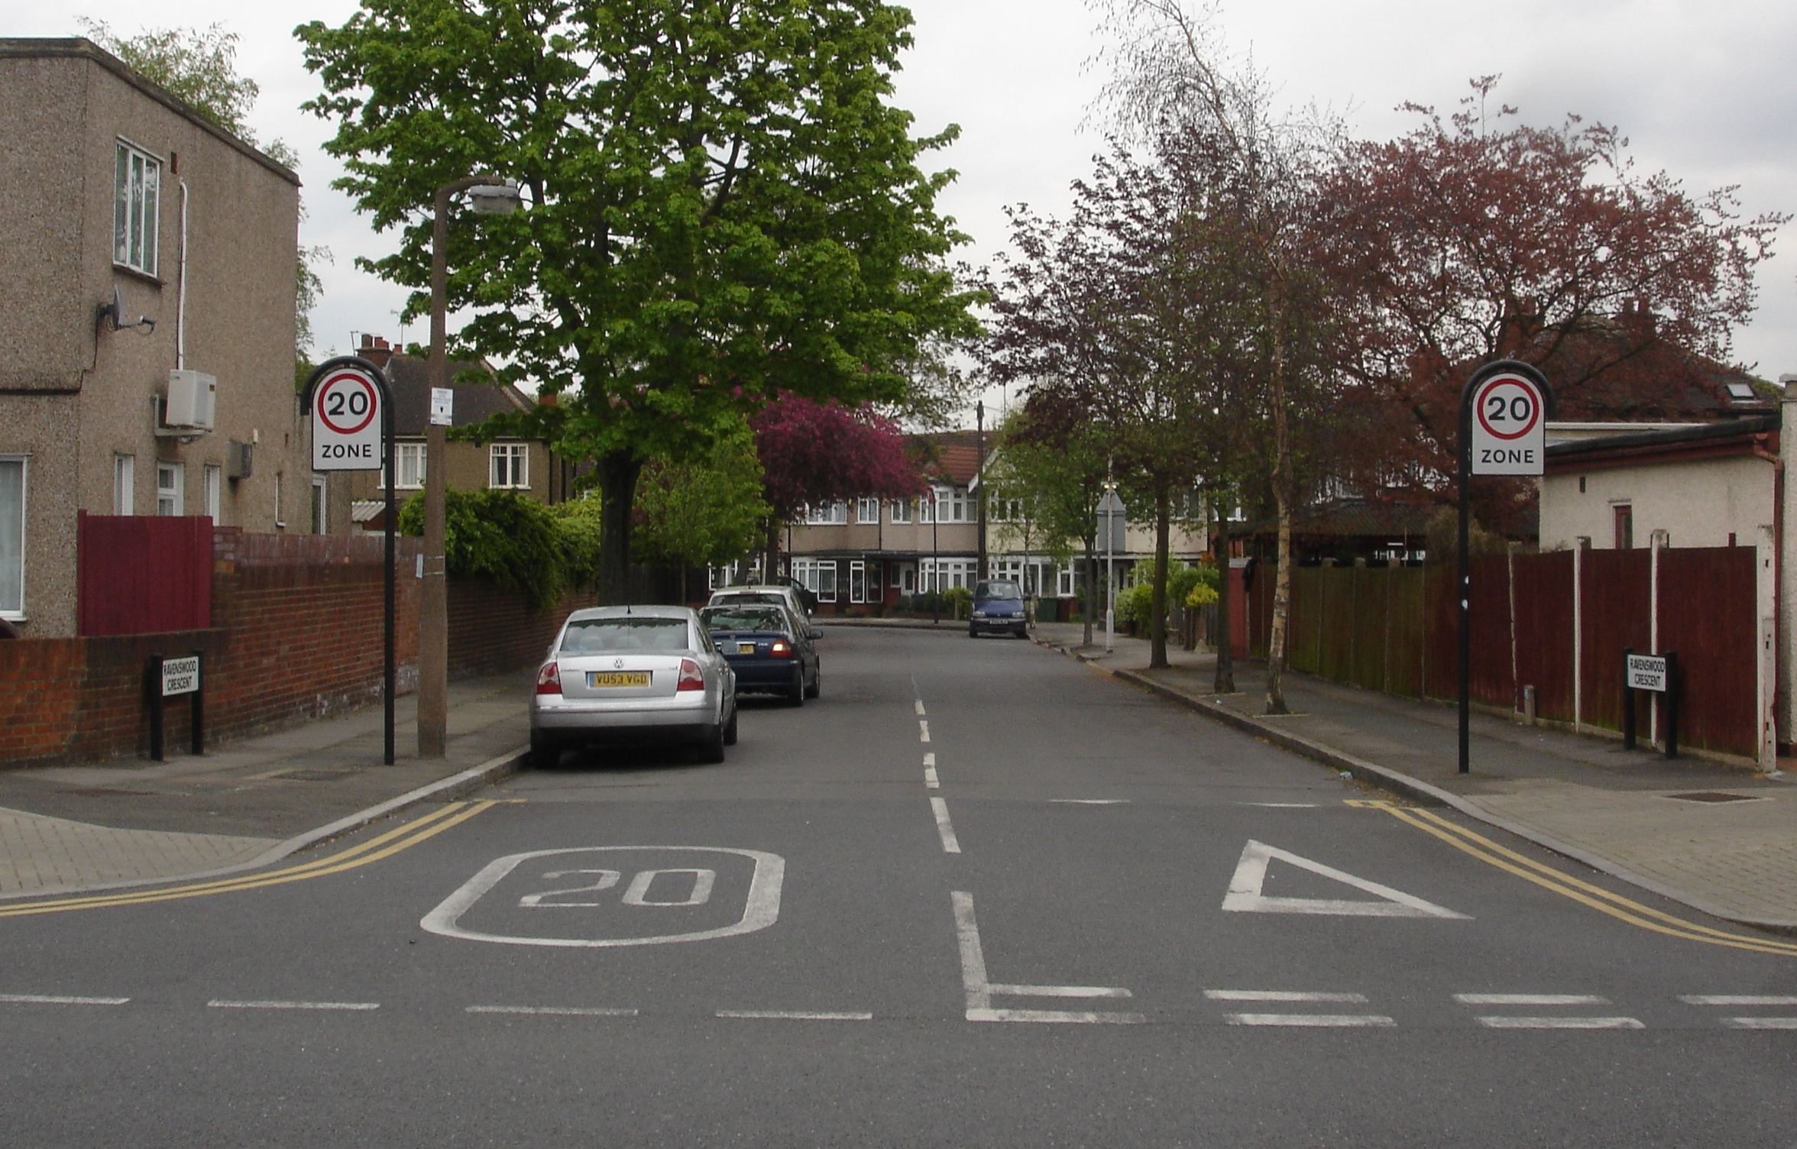
A large number of evaluation studies have demonstrated a link between the introduction of 20mph zones and a subsequent reduction in casualties. The size of the reductions and the consistency of results over a wide number of areas are further evidence for this link. There is similarly strong evidence showing the benefits of traffic calming measures, which are used in 20mph zones. A key benefit of a 20mph zone is that pedestrian survival rate is increased to 97% when vehicles travel at speeds below 20mph.
Harrow has a target of increasing the number of schools located within a 20mph zone in the borough to 70% of schools by 2020. The impact of introducing a 20mph zone is not only a decrease in accidents but also an increase in the local perception of safety. The resulting reduction in any traffic movement will help to reduce the number of road traffic accidents and generally improve road safety for all road users.
At present around 50% of schools are located in 20-mph zones within the borough, however, over the coming years the Council is proposing to implement or expand further zones where traffic conditions, particularly around schools, could be improved by their introduction.
A list of all 20mph zones and traffic calmed areas in the borough is included in Appendix A.

6.2.4 Local Safety Schemes

To decide where to introduce measures to reduce personal injury accidents, the latest 3 year accident data is considered. Because the number of people killed or seriously injured in Harrow is low compared with other boroughs, it is sometimes difficult to identify clusters where only the most serious accidents have taken place. For this reason although our priority is to reduce KSI accidents, the borough considers all accidents when looking at casualty data. The latest 3 years of casualty data is shown in a map in Appendix B and the effectiveness of implementing local safety schemes is shown in Appendix C.

The scheme development work planned is focussed on the analysis of personal injury road traffic accidents data supplied by the Metropolitan Police and detailed assessments of how accidents have occurred and the layout of the environment in which they take place.

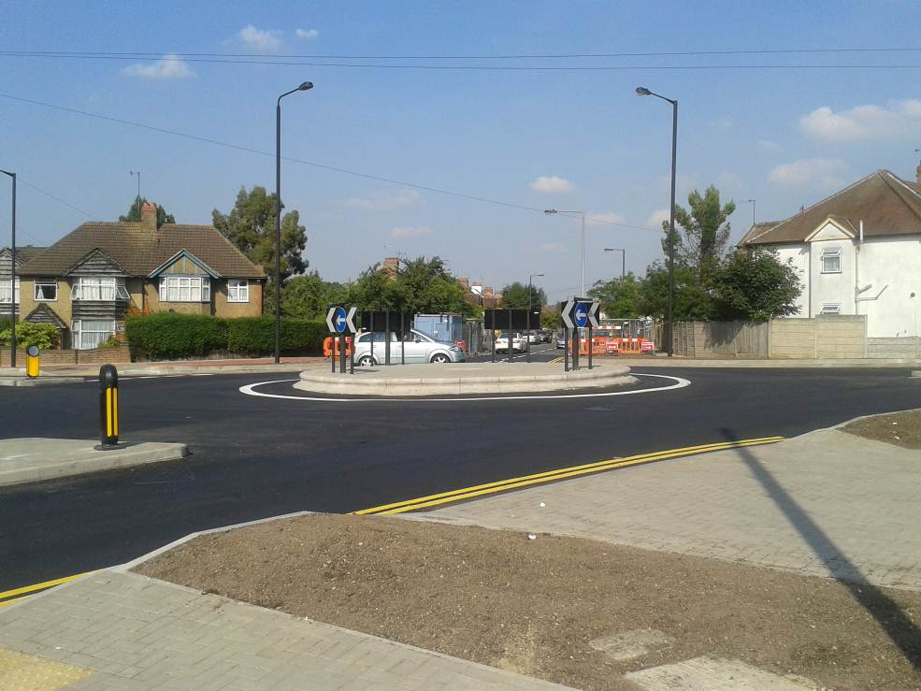

New roundabout layout – Roxeth Green Ave/ Rayners Lane / Eastcote lane

Although personal injury accidents are random events, many commonly occurring factors are shared in accidents and it is the identification of these factors, which lead to the development of engineering remedial measures. Engineering measures are therefore developed exclusively on that basis.
Future schemes include a programme of works aimed primarily at addressing accidents involving killed or seriously injured, motorcyclists and cycles. This ensures that key borough priorities are addressed as well as the national priorities.

6.2.5 School Travel Plans
The Council works with all local schools to help them introduce School Travel Plans. These plans frequently require both physical measures to be introduced to the local road network as well as relevant publicity and information to be provided. The entire school community is encouraged to identify the problems and dangers that prevent them from walking or cycling to and from school.
These comments are looked at by traffic engineers who develop proposals to implement traffic engineering schemes that will improve walking and cycling routes. The studies also highlight to the schools, the safety and environmental problems caused by cars on the school run and involve staff, pupils and parents in looking at ways that the school journey may be improved.
School Travel Plans are a powerful way to influence parental behaviour and have been proven to encourage walking to school and actually reduce car use. Schools are encouraged to apply for accreditation through STARS (Sustainable Travel: Active, Responsible, Safe), A Transport for London led scheme. STARS provide bronze, silver and gold standards of accreditation based on the performance of the STP. In general terms the more initiatives a school delivers and the greater the changes in behaviour, the higher the STARS Accreditation award.

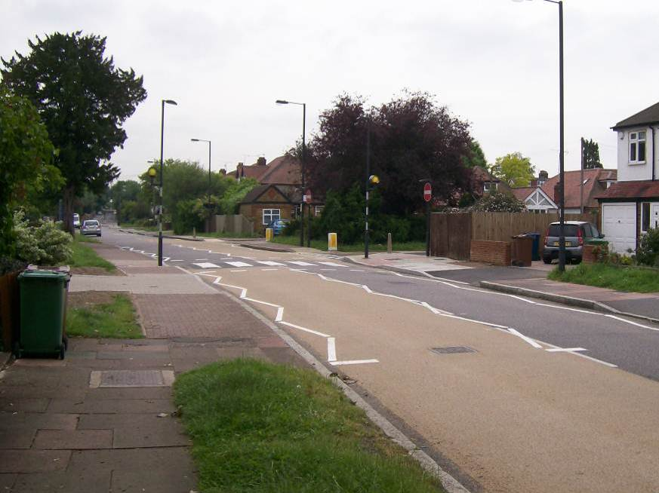

Zebra crossing installed as part of a safer route to school project close to Cannon Lane School

6.2.6 Localised Safety Parking Programme (LSPP)

Poor and dangerous parking can frequently limit how safe it is for pedestrians to cross the street and vehicles to access local buildings. Poor parking can reduce site lines which results in both drivers and pedestrians taking higher risks to go about their daily business.

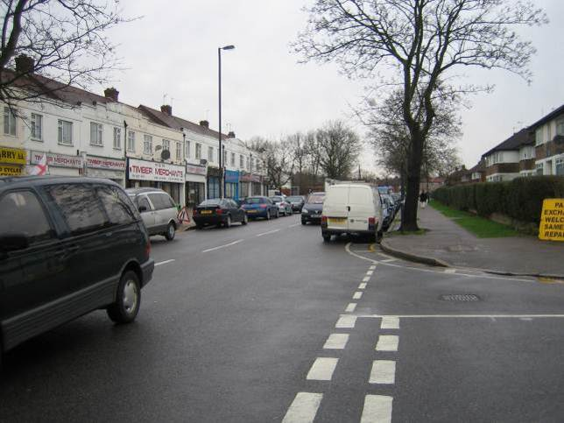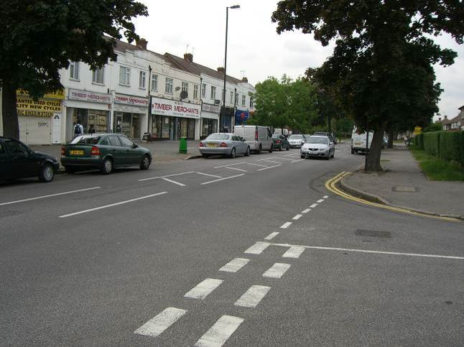

Visibility before measures introduced Access and visibility improved

The LSPP deals with isolated locations where parking problems and issues occur. Typically remedial measures consist of proposals for single or double yellow lines at junctions, bends and narrowings in order to improve access. These measures also support the well-established principles in The Highway Code.

The number of requests far exceeds the financial and staff resources to enable them all to be implemented and consequently a formal appraisal system is utilised to prioritise schemes and direct the limited resources to the neediest locations.

6.3 Enforcement

Safety issues are a fundamental consideration for all national and local traffic regulations and their implementation. However, without proper enforcement, the traffic regulation and its safety impact is futile. Changing attitudes towards some issues is a significant help in minimising the level of enforcement required, for example, the change in attitudes to drink driving. However, regulations do need to be well enforced to maximise their impact.

The Police are responsible for enforcing speed limits and the council works closely with the Traffic Police (currently based in Alperton Police garage) and the Police Safer Neighborhood teams to share speed survey data to help target enforcement across the borough.
Safety regulations in Harrow are primarily promoted and enforced through the use of speed and red light cameras, speed activated signs.

6.3.1 Speed and red light cameras
Camera enforcement is one of the tools used in Harrow to improve safety. The London Safety Camera Partnership (LSCP) is responsible for implementing a comprehensive camera safety programme to reduce speed and red light running road crash casualties in London. Recently all speed cameras in London have been upgraded to digital style cameras.
Camera enforcement is one of the tools used in Harrow to improve safety The London Safety Camera Partnership exists to do three things:

- Reduce death and serious injury caused by speeding and red light running in London;
- Raise awareness about the dangers and consequences of speeding and red light running; and
- Meet the Government and the Mayor's 2020 targets for casualty reduction.
To achieve these aims the Partnership operates a combination of fixed speed, mobile speed and red light camera sites across London, making it a safer place for everyone.
The Partnership consists of the following organisations:
Transport for London (TfL)
Metropolitan Police Service
City of London Police
Her Majesty's Courts Service
London Councils
The objectives of the partnership are:

- To operate in targeted collision “hotspots” and areas of community concern around London;
- To improve driver behaviour using sustained education and enforcement; and
- To increase the support of Londoners for safety camera deployment.

Harrow works with the LSCP regarding camera installations. Since April 2007, the criteria for introducing speed and red light cameras in London are as follows:

Speed Cameras
In the most recent 36 month period there must be a collision history along the length of road of 3 Killed or Seriously Injured collisions, 2 of which must be speed related.

Red Light Cameras

In the most recent 36 month period there must be a collision history at the junction, and on the same arm, of 1 Killed or Seriously Injured collision and 1 other personal injury collision (slight). Both of these collisions must have been caused by a vehicle 'Disobeying Automatic Traffic Signals' (running a red light).

Harrow keeps the location of red light and speed cameras under continual review.
A map and information showing the location of red light and speed cameras in Harrow are provided in Appendix D.

6.3.4 Speed activated signs (SAS)
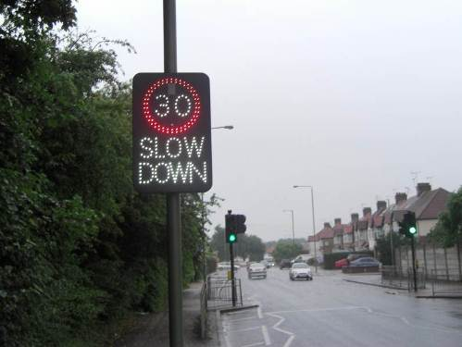
Speed (or vehicle) activated signs are used to address the problem of inappropriate speed where conventional signing has not been effective or where engineering measures would be unsuitable or unfeasible due to site constraints.
The council currently has ninety five SAS located at strategic sites throughout the borough.

6.3.5 Speed limits

The primary purpose of a speed limit is to indicate the maximum permitted speed to be driven on a road or within a defined area. Associated to the purpose of speed limits is the need to set a limit that is appropriate for the particular road and the purposes for which it is used. The 30mph limit is applicable on all roads in England and Wales where street lighting is present unless signs show otherwise. These areas are also more often than not built-up areas.

Speed limits should fit into a rational and easily understood hierarchy if they are to be observed by drivers. Before deciding to change an existing speed limit the Traffic Authority must consider all the relevant factors, including:
- accident and casualty savings
- improvement to the environment
- improvement in conditions and facilities for vulnerable road users
- reduction in public anxiety
- increased journey times for motorised traffic
- costs of implementation
- costs of engineering measures and their maintenance
- negative environmental impact of engineering measures
- costs of enforcement
If it is considered that a change in the speed limit is the best course of action, then a speed limit Order has to be made. This involves a statutory legal process.

6.3.6 Civil enforcement officers (Parking attendants)

The Council directly employs its own parking enforcement staff. In addition, at times suitably qualified agency staff assists in the enforcement process. The presence of civil enforcement officers is a deterrent to dangerous parking. Dangerous parking at junctions and bends can impair visibility and may lead to road accidents as people step out between cars with only limited view of the line of traffic. The perception of well-enforced parking regulations also increases the perception of a well-enforced road network.

7. MONITORING

The following activities will continue to be monitored:

- All road accidents but particularly those involving killed or seriously injured, those involving cyclists or motorcyclists and those involving young people
- Number of schools updating their travel plans and achieving an accredited status
- Effectiveness of all Local safety schemes and 20mph zones.

8 . PARTNERSHIPS

There is close partnership between Engineers, Road Safety Officers, school crossing patrols, the Police, Fire and Ambulance services, bus operators and Council’s enforcement staff on road safety and traffic management issues. A new focus team has been established with these partners that will meet 4 times a year to discuss joint initiatives on how to reduce casualties in the Borough.

Harrow’s team of civil enforcement officers provide an on-street parking enforcement programme.

The Mayor of London has responsibility for developing and implementing safe transport facilities throughout London. The Mayor can encourage bus operators to provide bus driver training to reduce collisions and to make journeys smoother.

The Police play a key role in enforcing traffic regulations and speed limits. Their direct involvement in dealing with collisions and accident data collection is vital in analysing collisions.

The Department for Transport (DfT) provides general guidance on road safety issues and sets national standards for driver training and vehicle standards and undertakes national campaigns.
Transport for London play a large role in supporting London Boroughs in Road Safety initiatives and also provide funding for Local Safety Schemes, School Travel Plan implementation schemes, walking and cycling schemes, 20mph schemes, Education, Training and Publicity promotion in schools and for the continued development of School Travel Plans. The Department for Education and Skills also provide bursaries to local authorities and capital funding to schools to assist in the development of school travel plans.

9. FUNDING

Funding for all road safety schemes in Harrow is predominantly provided by TfL through a borough formula funding allocation.

BP/JA Oct 2015

Appendix A: 20mph zones and traffic calmed areas n London Borough of Harrow
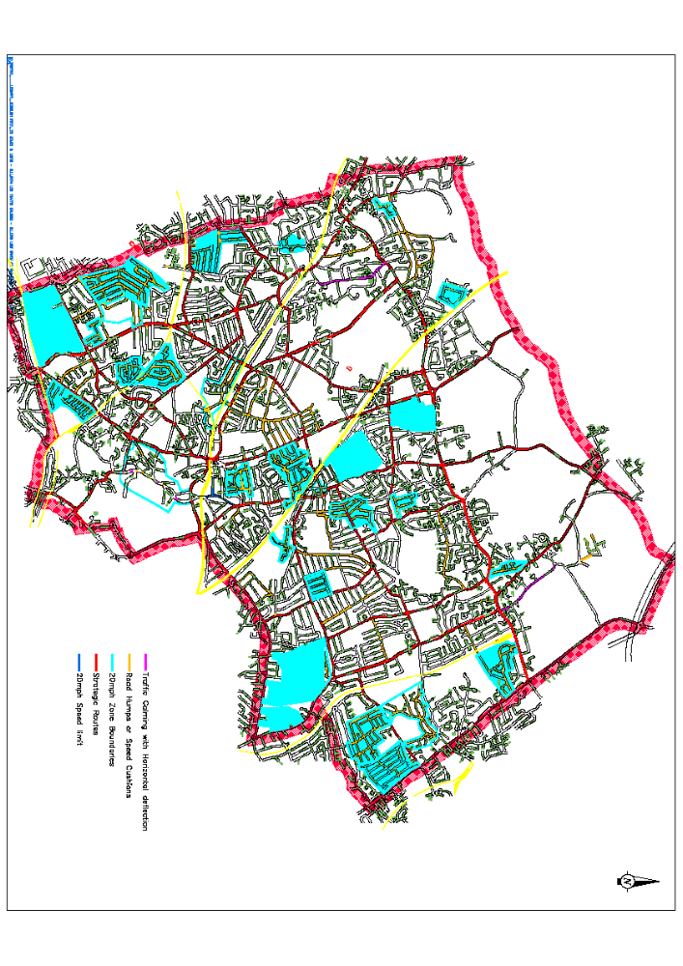

Appendix B: Road casualty maps

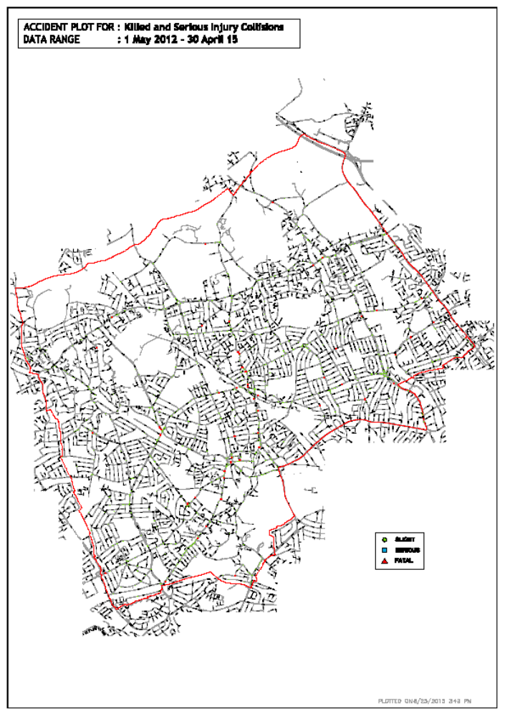

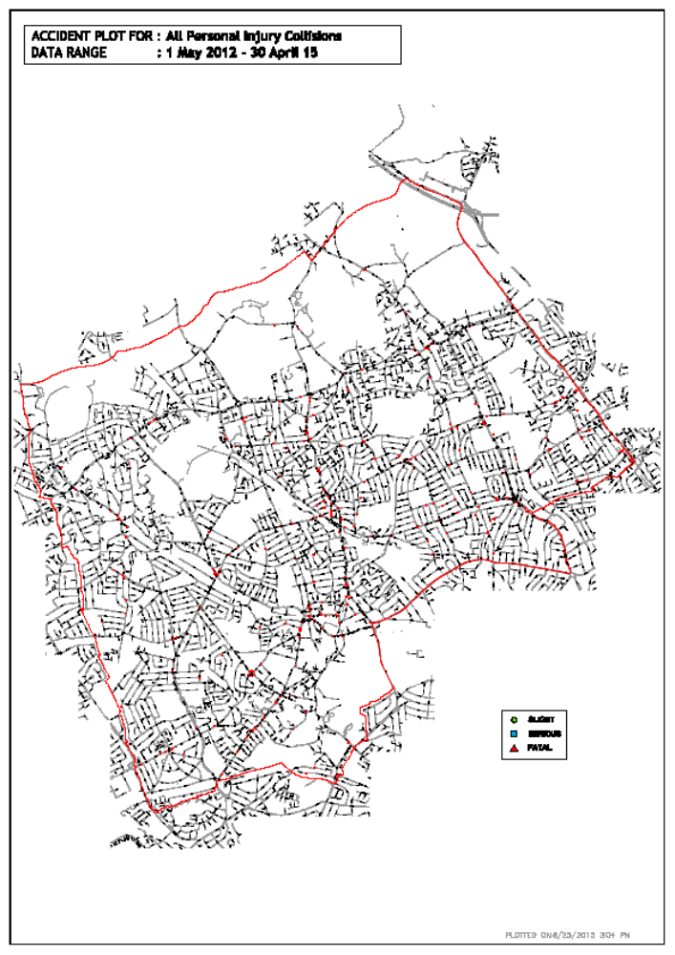

Appendix C: Effectiveness of Local Safety Scheme implementation

The following table shows the change in accidents between 2009 -2015 following the implementation of local safety schemes: (updated Sept 15)

Scheme Name | Date scheme implemented | Before implementation |  |  | After implementation
Local Safety Schemes |  | Killed | Seriously injured | slights | Killed | Seriously injured | slights
George V – traffic signals | Sept -10 | 0 | 2 | 11 | 0 | 0 | 1
Northolt Road | Dec- 10 | 0 | 1 | 36 | 0 | 2 | 7
Uxbridge Road – Hatch End | Apr -11 | 2 | 6 | 12 | 0 | 0 | 2
Shaftesbury Circle** | Apr -13 | 0 | 2 | 9 | 0 | 1 | 8
Old Redding** | May-13 | 0 | 4 | 26 | 0 | 2 | 5
Old Church Lane** | Jan-14 | 0 | 0 | 5 | 0 | 0 | 2
London Road** | Mar-14 | 0 | 0 | 8 | 0 | 0 | 2
High Street, Pinner | TBC | 0 | 3 | 11 | - | - | -
High Road , Harrow Weald | TBC | 0 | 4 | 28 | - | - | -
Total |  | 2 | 22 | 146 | 0 | 5 | 27

** Accident numbers shown are for the three years before and three years after implementation or up to end of Apr 2015 if less than three years.

Of the first seven schemes above this shows a reduction in KSI`s of 71% and 75% for slight casualties.

Appendix D: Location of speed and red light camera sites

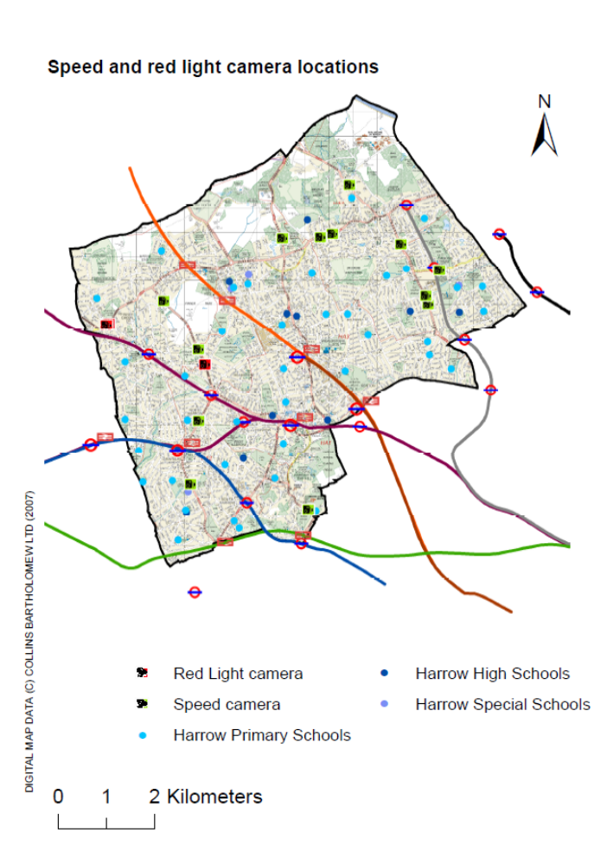

Red light Running Camera Sites

LOCATION | DIRECTION
- A404 Uxbridge Road Pinner Green j/w Elm Park Road. | Westbound
- A404 George V Avenue, Pinner j/w Headstone Lane. | Southbound
- A404 Pinner Green j/w Pinner Hill Road | Eastbound

Speed Camera Sites

LOCATION | DIRECTION & SPEED LIMIT
- A4140 Honeypot Lane, Stanmore, near j/w Broadcroft Avenue | Northbound  40mph
- A4140 Honeypot Lane, Stanmore, north of j/w Wigton Gardens. | Southbound  40mph
- A4140 Marsh Lane, Stanmore, opposite j/w Silverston Way. | Southbound  30mph
- A409, Brookshill, Harrow Weald j/w Harrow Weald Park. | Southbound  30mph
- A404 St Thomas’ Drive, Pinner j/w Briants Close | Northbound  40mph
- A404 St Thomas’ Drive, Pinner j/w Briants Close | Southbound  40mph
- A404 George V Avenue, Pinner j/w Elmcroft Crescent | Northbound  30mph
- A404 George V Avenue, Pinner j/w Elmcroft Crescent | Southbound  30mph
- A4140 Stanmore Hill, Stanmore j/w Wood Lane | Southbound  30mph
- A4090 Alexandra Ave, near j/w Drake Rd | Southbound  30mph
- A4090 Alexandra Ave, near j/w Drake Rd | Northbound  30mph
- A4005 Sudbury Hill near j/w Greenford Rd | Southbound  30mph
- A410 Uxbridge Rd by Hathaway Close | Westbound 30mph
- A410 Uxbridge Rd by Masefield Ave | Eastbound 30mph
- B461 Whitchurch Lane near Donnesfield Ave | Westbound  30mph
- B461 Imperial Drive near Farm Avenue | Northbound  30mph
- B461 Imperial Drive near Farm Avenue | Southbound  30mph

